**ITU SWE 525 Version Control with Git Final Examination 09/04/2016**

Name: ITU ID:



This exam is take comprehensive test of your knowledge of Git and Version Control concepts covered in the class. The exam represents 25% of your course grade. 10 Exercise sections namely Case Studies and problems on 28 numbered pages, including the cover page and extension blank pages..

I have used University of Michigan testing method of exhaustive test that tests your judgment, attitude and knowledge. I have given you a lot of questions in this test of variable difficulty levels and variable marks based on difficulty level is allotted to each question. Marks/points allotted for each question is not published to students as it varies. There are no penalties for wrong answer or skipping a question or not answering a question. I will leave it up to you to attempt as many questions as you can in 4.5 hours given to you. You can use any resource you have access to answer the questions. You can take 30 more minutes if needed.

Be sure to write your name, student ID, time/date when you started & ended the exam. This exam should take around 4.5 hours to complete You can take 30 minute extension if needed. Submit the exam to EMS when done. You don’t have to type. You can print and complete exam manually and scan it. Good Luck!

Don’t cheat by copying other student’s answers it will not help you in a long run! Try to learn the concepts of Git Version Control! It will help you in your career.

1. Please explain the git Flow and write set of commands that produces following flow. Give tag to each subquestion and push it to git repository. Put the link to your repo.

a.

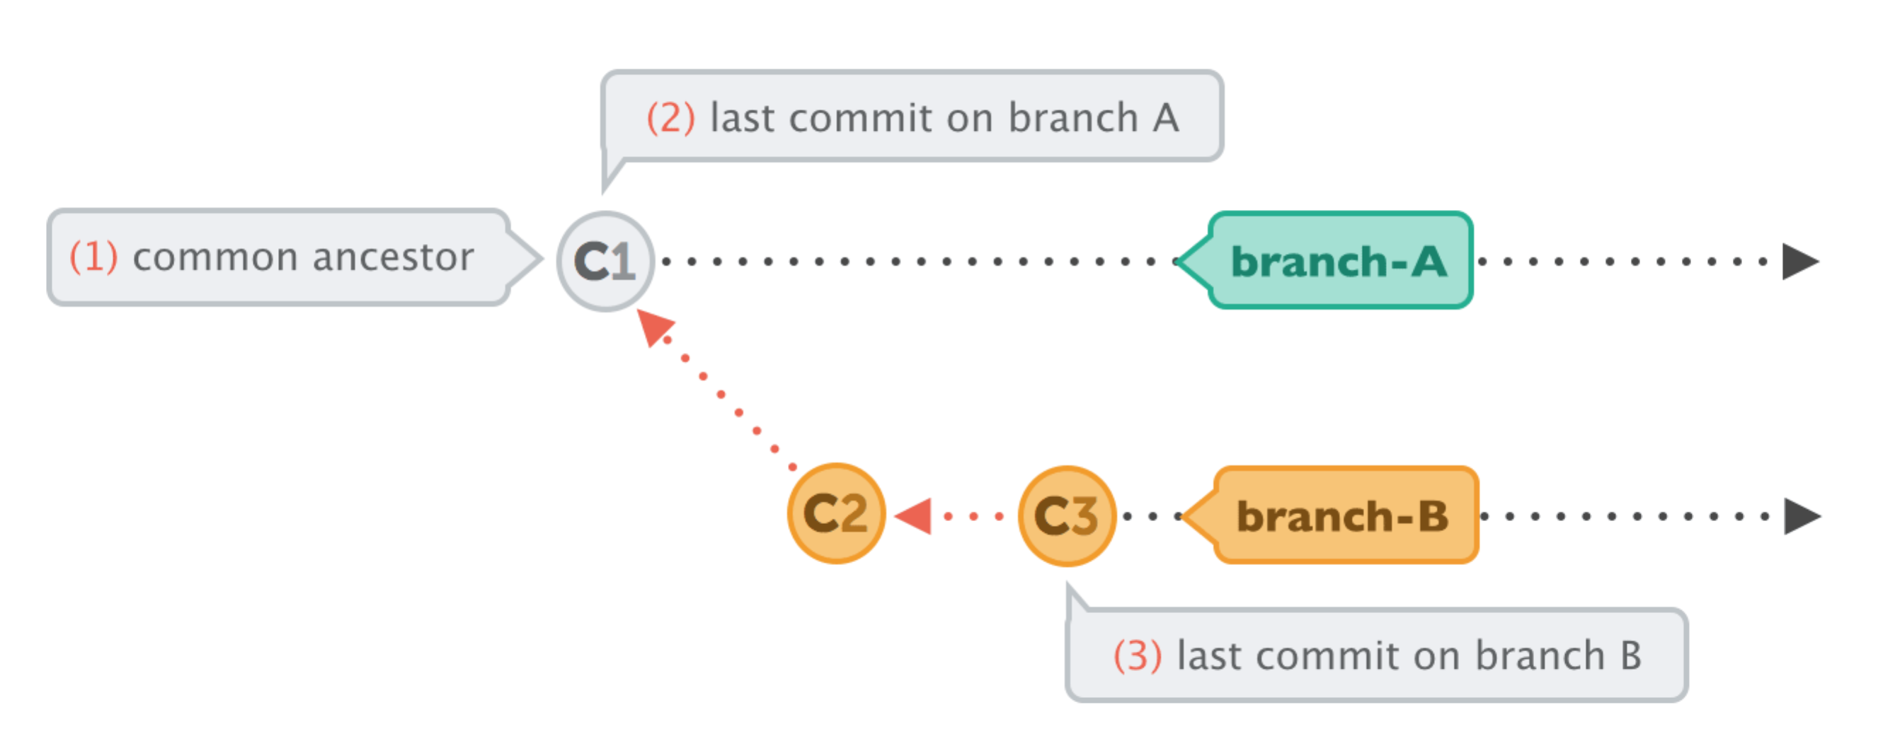

**Sol:**

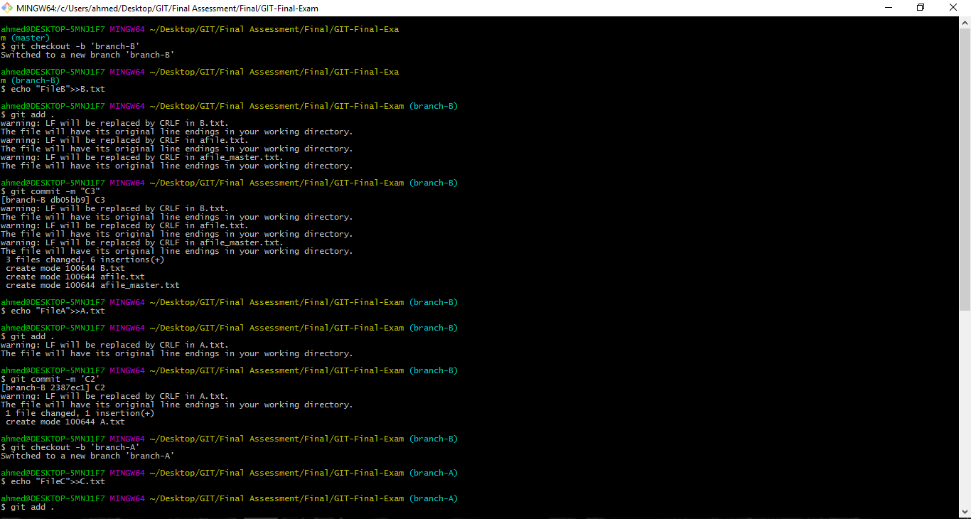

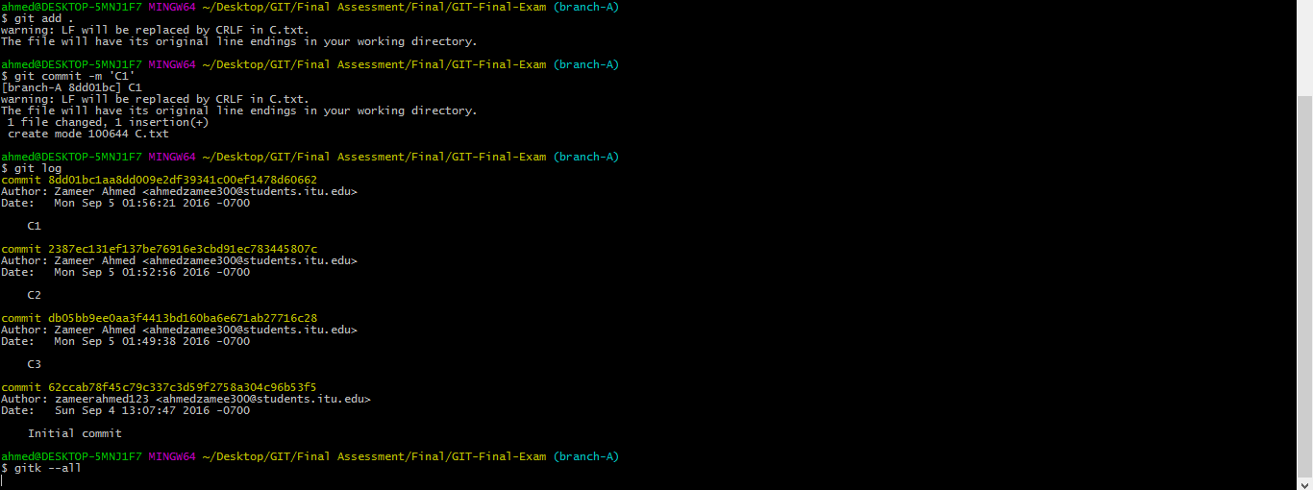

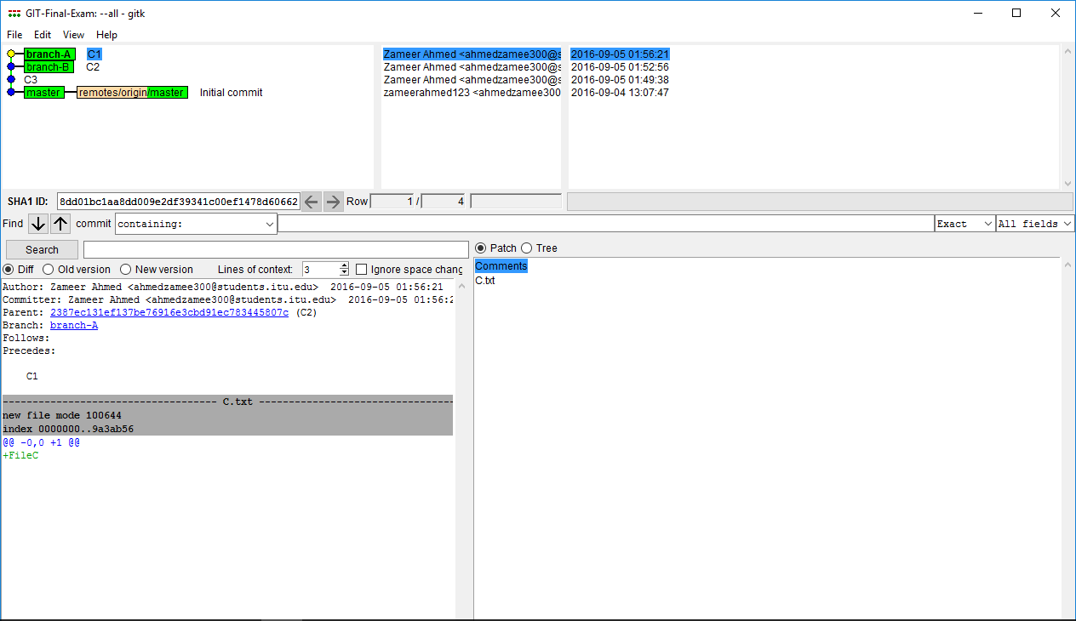

$ mkdir Question1A

$ cd Question1A

$ git init

# Branch-A created

$ git checkout -b branch-A

Switched to a new branch 'branch-A'

$ git branch

* branch-A

touch C1.txt

$ git add C1.txt

$ git commit -a -m "C1"

# Branch-B created

$ git checkout -b branch-B

Switched to a new branch 'branch-B'

$ git branch

branch-A

* branch-B

touch c2.txt

$ git add c2.txt

$ git commit -a -m "C2"

touch C3.txt

$ git add C3.txt

$ git commit -a -m "C3"

$git remote add origin <https://github.com/zameerahmed123/GIT-Final-Exam.git>

$ git tag -a v0.1 -m "Two branches created"

$ git push origin v0.1

$ git push origin branch-B

$git checkout branch-A

$ git push origin branch-A

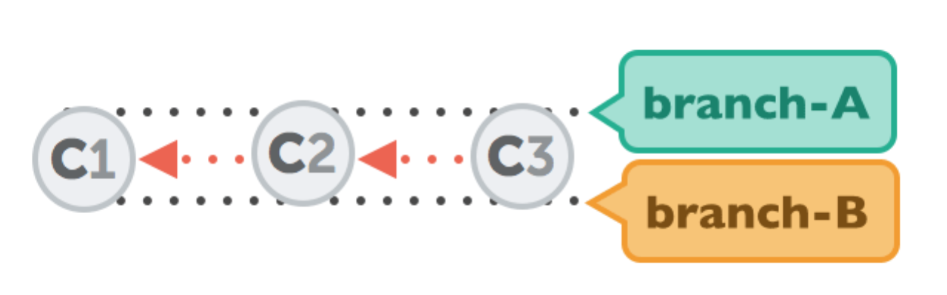b.

**Sol:**

$ git checkout branch-A

Switched to branch 'branch-A'

$ git merge --ff-only branch-B

Updating f18adfe..f643c03

Fast-forward

c2.txt | 0

c3.txt | 0

2 files changed, 0 insertions(+), 0 deletions(-)

create mode 100644 c2.txt

create mode 100644 c3.txt

$ git tag -a v0.2 -m "Merge branch using fast forward

$ git push origin v0.2

$ git push branch-A

$ git checkout branch-B

$ git push branch-B

c.

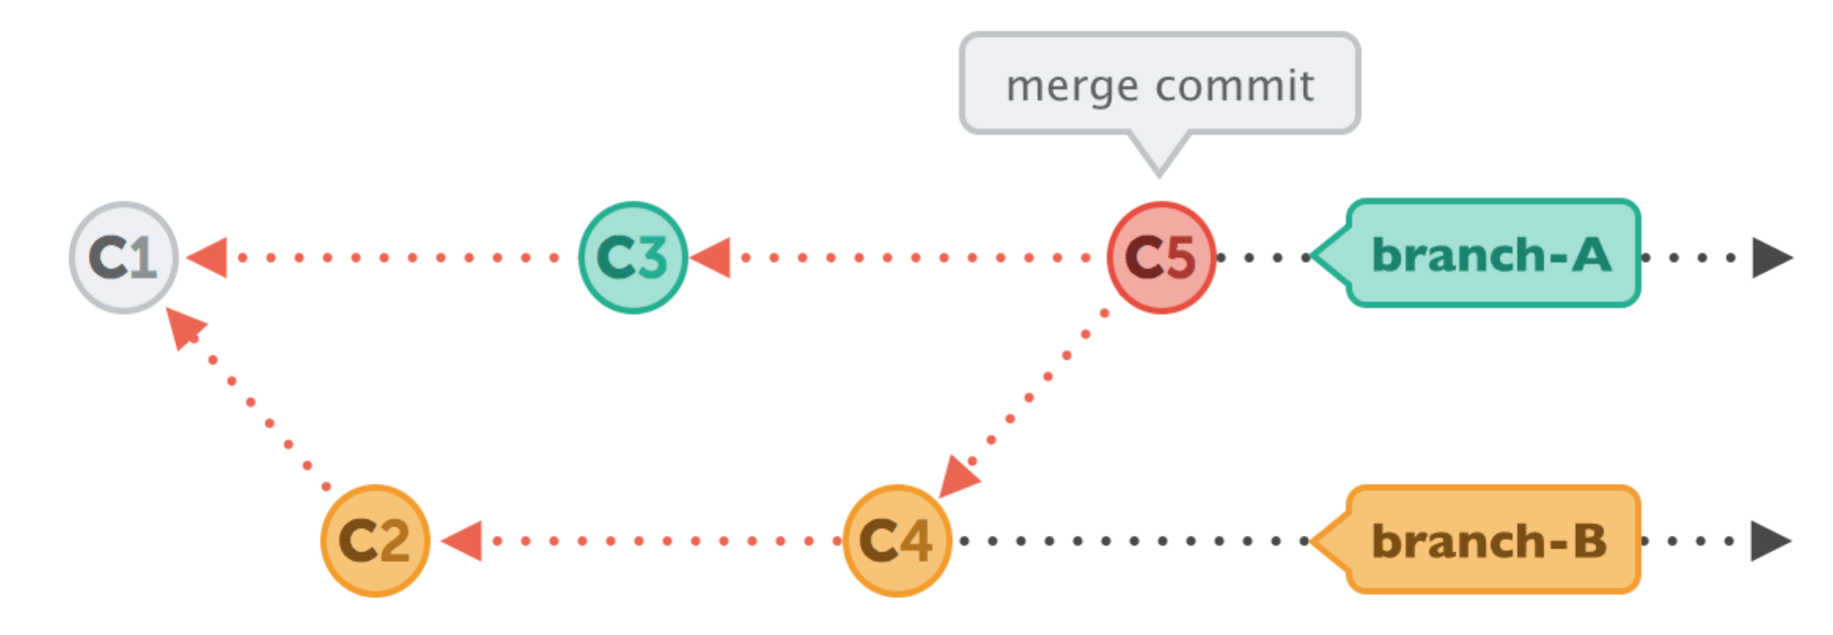

**Sol:**

$ git checkout branch-A

Switched to branch 'branch-A'

$ touch C5.txt

$ git add .

$ git commit -m "C5"

$ git checkout branch-B

Switched to branch 'branch-B'

$ touch C6.txt

$ git add .

$ git commit -m "C6"

$ git checkout branch-A

Switched to branch 'branch-B'

$ git merge branch-B

$ git tag -a v0.3 -m "Branch-B merged with branch-A"

$ git push origin v0.3

$ git push origin branch-A

$ git checkout branch-B

$ git push origin branch-B

d.

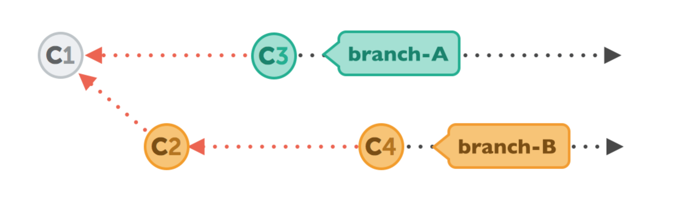

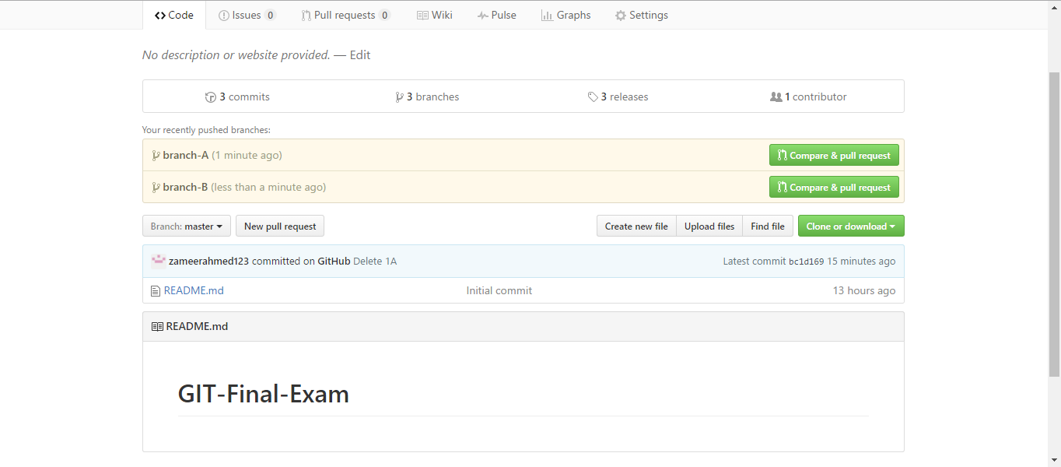

$ git checkout branch-A

$ mkdir PartD

$ cd PartD

$ git merge branch-B

$ touch C1.txt

$ git add .

$ git commit -m "C1"

$ touch C2.txt

$ git add .

$ git commit -m "C2"

$ git checkout branch-B

$ touch C2.txt

$ git add .

$ git commit -m "C2"

$ touch C4.txt

$ git add .

$ git commit -m "C4"

$ git tag -a v0.4 -m "Two Separate branch"

$ git push origin v0.4

$ git push origin branch-B

$ git push origin branch-A

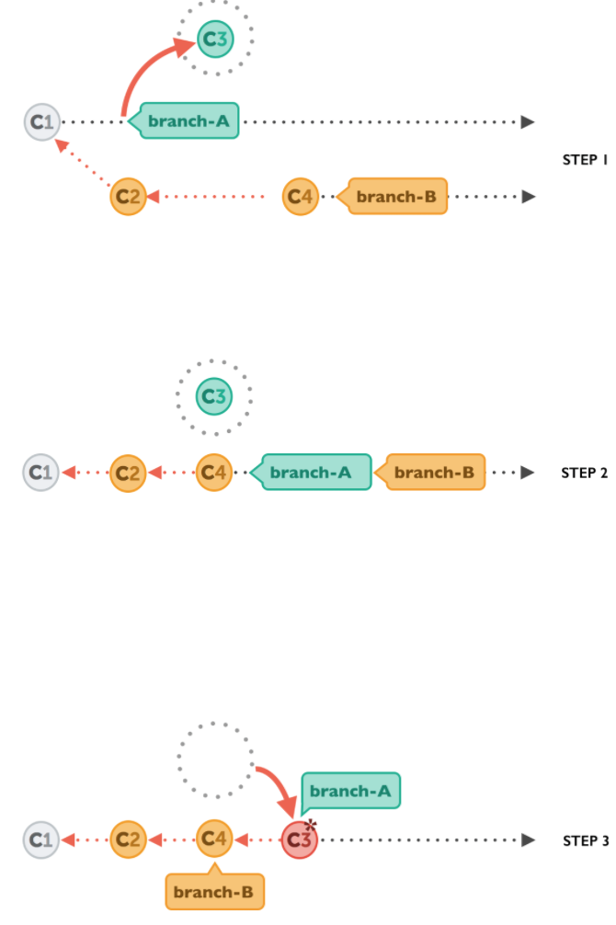e.

**Sol:**

$ cd PartD

$ git merge branch-B

$ touch C1.txt

$ git add .

$ git commit -m "C1"

$ git checkout branch-B

$ touch C2.txt

$ git add .

$ git commit -m "C2"

$ touch C4.txt

$ git add .

$ git commit -m "C4"

$ git checkout branch-A

$ touch C3.txt

$ git add .

$ git stash

$ git checkout branch-B

$ git merge branch-A

$ git checkout branch-A

$git stash list

$ git stash pop

$ git tag -a v0.5 -m "Stash and merge"

$ git push origin v0.5

$ git push origin branch-B

$ git push origin branch-A

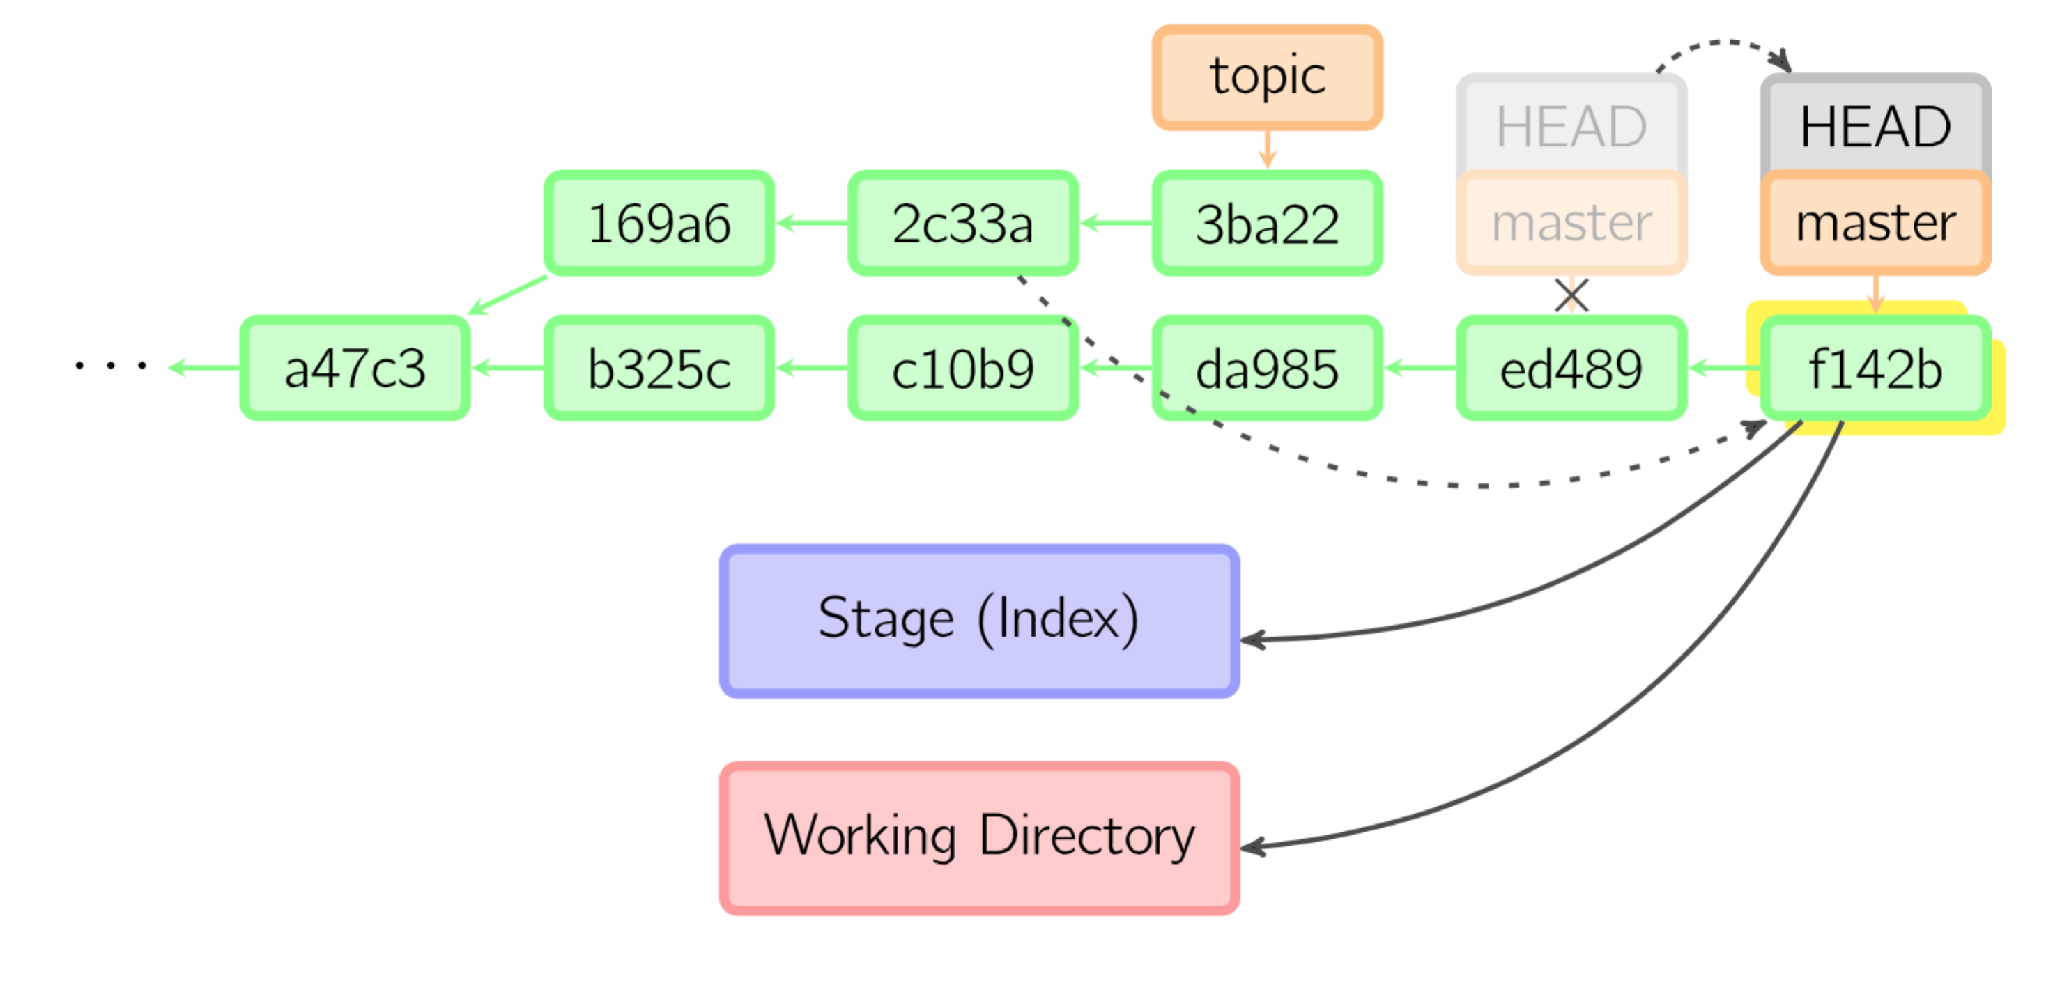**f.**

**g.**

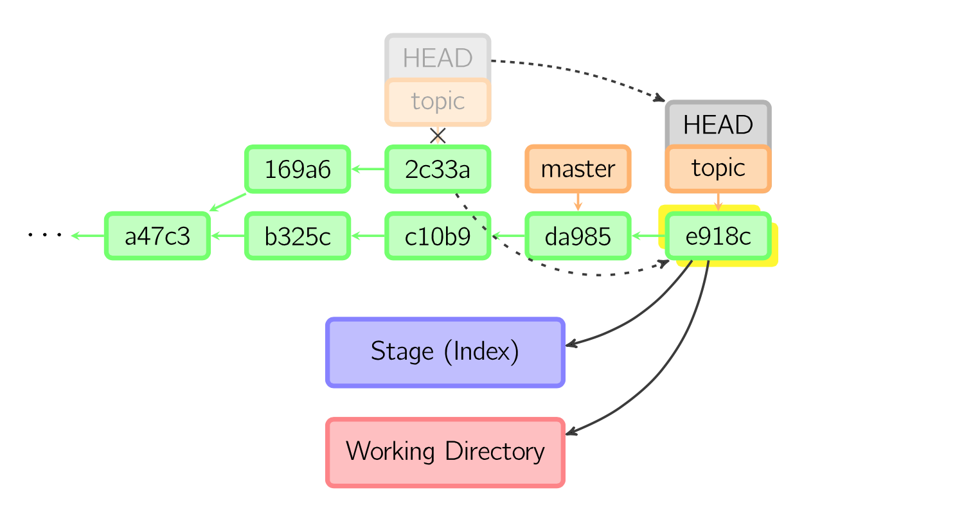

**2. Solve the following exercise. Complete the exercise and You should be able to achieve the flow drawn at the end of the code. Draw your own version of the flow from following code and compare to the one attached below.**

**create a new feature and push it to develop for testing**

git checkout master

git pull origin master

git checkout -b feature/c1234-adding_this

git add

git commit [... reiterate as many time as needed]

git push origin feature/c1234-adding_this

git checkout develop

git pull origin develop

git merge --no-ff feature/c1234-adding_this

git push origin develop

**publish a feature to master for the pre-release**

git checkout master

git pull origin master

git merge --no-ff feature/c1234-adding_this

git push origin master

**push master to production**

git checkout production

git pull origin production

git merge --no-ff master

git tag -a mytag -m “mytag”

git push origin production

git push –tags

**Create a hotfix**

git checkout production

git pull origin production

git checkout -b hotfix/i1234-fix-that

git push origin hotfix/i1234-fix-that

git checkout production

git merge --no-ff hotfix/i1234-fix-that

git push origin production

git checkout master

git rebase production

You should be able to achieve following flow at the end of this exercise. Do this in your Git and push your repo to github. Put the link in this document to your github with this question.

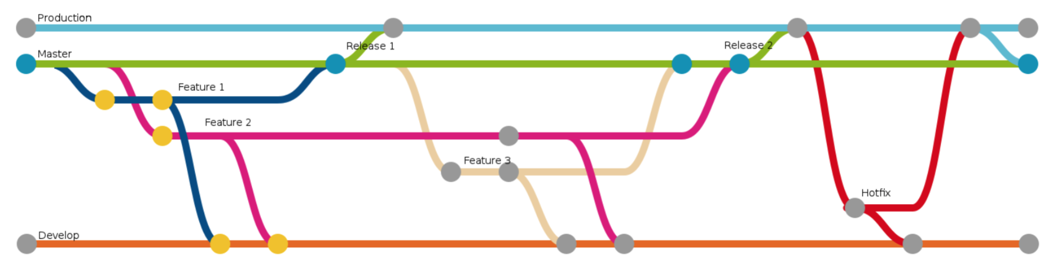

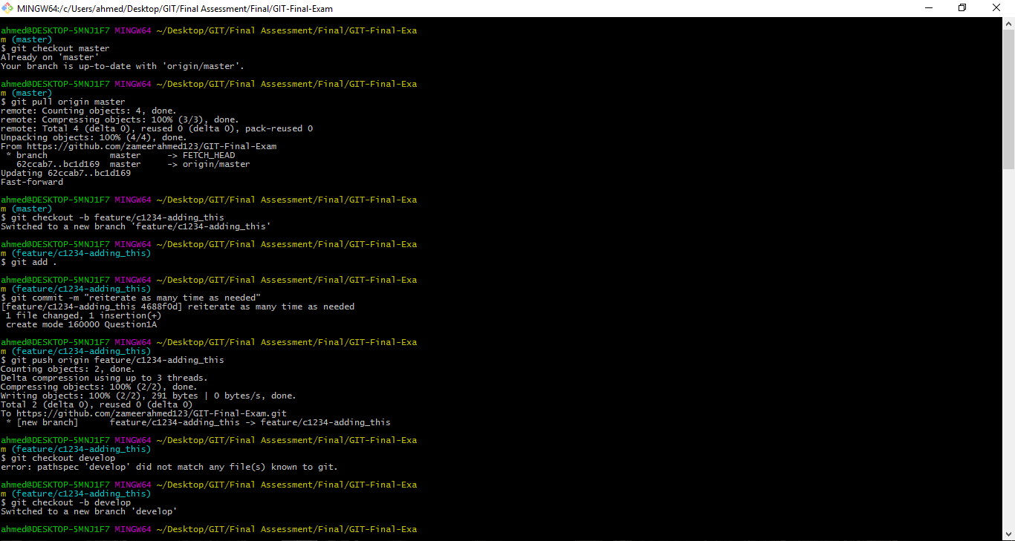

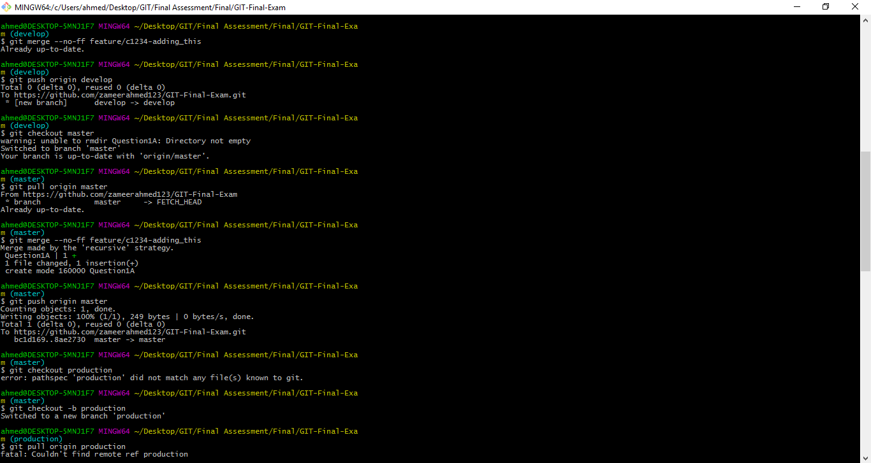

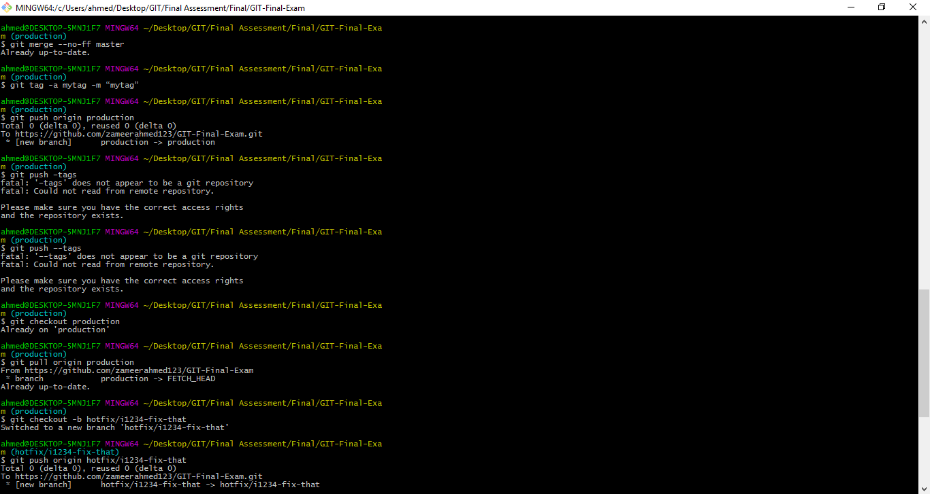

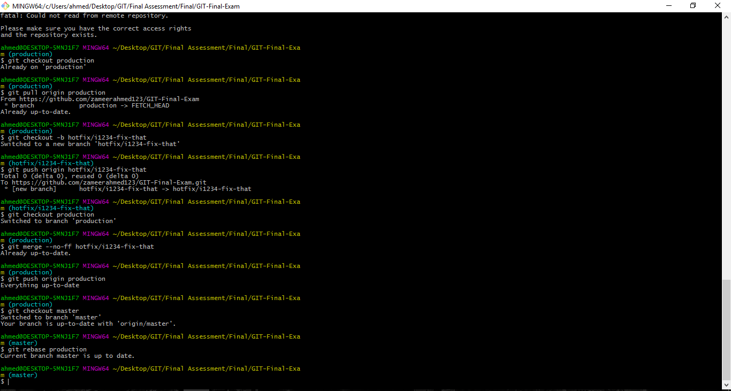

1. **What is Degenerate, speciality and normal merge?**
2. There are two common degenerate scenarios that lead to merges, and they are called already up-to-date and fast-forward.

**Already up-to-date:** When all the commits from the other branch (its HEAD) are already present in your target branch, even if it has advanced on its own, the target branch is said to be “already up-to-date.” As a result, no new commits are added to your branch. For example, if you perform a merge and immediately follow it with the exact same merge request, you will be told that your branch is already up-to-date:

# Show that alternate is already merged into master

$ git show-branch

! [alternate] Add alternate line 5 and 6

* [master] Merge branch 'alternate' --

- [master] Merge branch 'alternate'

+* [alternate] Add alternate line 5 and 6

# Try to merge alternate into master again

$ git merge alternate

Already up-to-date.

Fast-forward

A fast-forward “merge” happens when your branch HEAD is already fully present

and represented in the other branch. This is the inverse of the already up-to-date

case.

Since your HEAD is already present in the other branch (likely due to a common

ancestor), Git simply “tacks on” to your HEAD the new commits from the other branch. Git then moves your branch HEAD to point to the final, new commit. Naturally, the index and your working directory are also adjusted accordingly to reflect the new, final commit state. The fast-forward case is particularly common on tracking branches because they simply fetch and record the remote commits from other repositories. Your local tracking branch HEADs will always be fully present and represented, as that is where the branch HEAD was after the previous fetch operation.

**Specialty Merges:**

There are two special merge strategies:

The two special strategies are ours and subtree.

These merge strategies each produce a final commit, added to your current branch that represents the combined state of the merge:

Ours:

The ours strategy merges in any number of other branches, but it actually discards the changes from those branches and uses only the files from the current branch. The result of an ours merge is identical to the current HEAD, but any other named branches are also recorded as commit parents.

This is useful if you know you already have all the changes from the other branches but want to combine the two histories anyway. That is, it lets you record that you have somehow performed the merge, perhaps directly by hand, and that future Git operations shouldn’t try to merge the histories again. Git can treat this as a real merge no matter how it came to be.

Subtree:

The subtree strategy merges in another branch, but everything in that branch is merged into a particular subtree of the current tree. You don’t specify which subtree; Git determines that automatically

Normal Merges

These merge strategies all produce a final commit, added to your current branch, that represents the combined state of the merge:

Resolve:

The resolve strategy operates on only two branches, locating the common ancestor as the merge basis and performing a direct three-way merge by applying the changes from the merge base to the tip of the other branch HEAD onto the current branch. This method makes intuitive sense

Recursive:

The recursive strategy is similar to the resolve strategy in that it can only join two branches at once. However, it is designed to handle the scenario where there is more than one merge base between the two branches. In these cases, Git forms a temporary merge of all of the common merge bases and then uses that as the base from which to derive the resulting merge of the two given branches using a normal three-way merge algorithm.

The temporary merge basis is thrown away, and the final merge state is committed on your target branch.

Octopus:

The octopus strategy is specifically designed to merge together more than two branches simultaneously. Conceptually it is fairly simple; internally it calls the recursive merge strategy multiple times, once for each branch you are merging.

However, this strategy cannot handle a merge that requires any form of conflict resolution that would necessitate user interaction. In such a case, you are forced to do a series of normal merges, resolving the conflicts one step at a time.

1. **Study the following case study. Read through it. Perform the steps noted in this case. Push your work in a repository in GitHub. Put your GitHub repository link in this document. Explain what you understand from this case in this document in detail. Add your screenshots where applicable**

**Git Rebase**

Imagine you are working on that radical new feature. It’s going to be brilliant but it takes a while. You’ve been working on that for a couple of days now, maybe weeks.

Your feature branch is already six commits ahead of master. You’ve been a good developer and have crafted meaningful semantical commits. But there’s the thing: you are slowly realizing that this beast will still take some more time before it’s really ready to be merged back into master.

m1-m2-m3-m4 (master)

\

f1-f2-f3-f4-f5-f6(feature)

What you also realize is that some parts are actually less coupled to the new feature. They could land in master earlier. Unfortunately, the part that you want to port back into master earlier is in a commit somewhere in the middle of your six commits. Even worse, it also contains a change that relies on a previous commits of your feature branch. One could argue that you should have made that two commits in the first place, but then nobody is perfect.

m1-m2-m3-m4 (master)

\

f1-f2-f3-f4-f5-f6(feature)

^

|

mixed commit

At the time that you crafted the commit, you didn’t foresee that you might come into a situation where you want to gradually bring the feature into master. Heck! You wouldn’t have guessed that this whole thing could take us so long.

What you need is a way to go back in history, open up the commit and split it into two commits so that you can separate out all the things that are safe to be ported back into master by now.

Speaking in terms of a graph, we want to have it like this.

m1-m2-m3-m4 (master)

\

f1-f2-f3a-f3b-f4-f5-f6(feature)

With the work split into two commits, we could just cherry-pick the precious bits into master.

Turns out, git comes with a powerful command git rebase -i which lets us do exactly that. It lets us change the history. Changing the history can be problematic and as a rule of thumb should be avoided as soon as the history is shared with others. In our case though, we are just changing history of our local feature branch. Nobody will get hurt. Promised!

Ok, let’s take a closer look at what exactly happened in commit f3. Turns out we modified two files: userService.js and wishlistService.js. Let’s say that the changes to userService.js could go straight back into master whereas the changes to wishlistService.js could not. Because wishlistService.js does not even exist in master. It was introduced in commit f1.

*Pro Tip: even if the changes would have been in* one *file, git could handle that. We keep things simple for this blog post though.*

We’ve set up a [public demo repository](https://github.com/thoughtram/interactive-rebase-demo) that we will use for this exercise. To make it easier to follow, each commit message is prefixed with the pseudo SHAs used in the graphs above. What follows is the branch graph as printed by git before we start to split the commit f3.

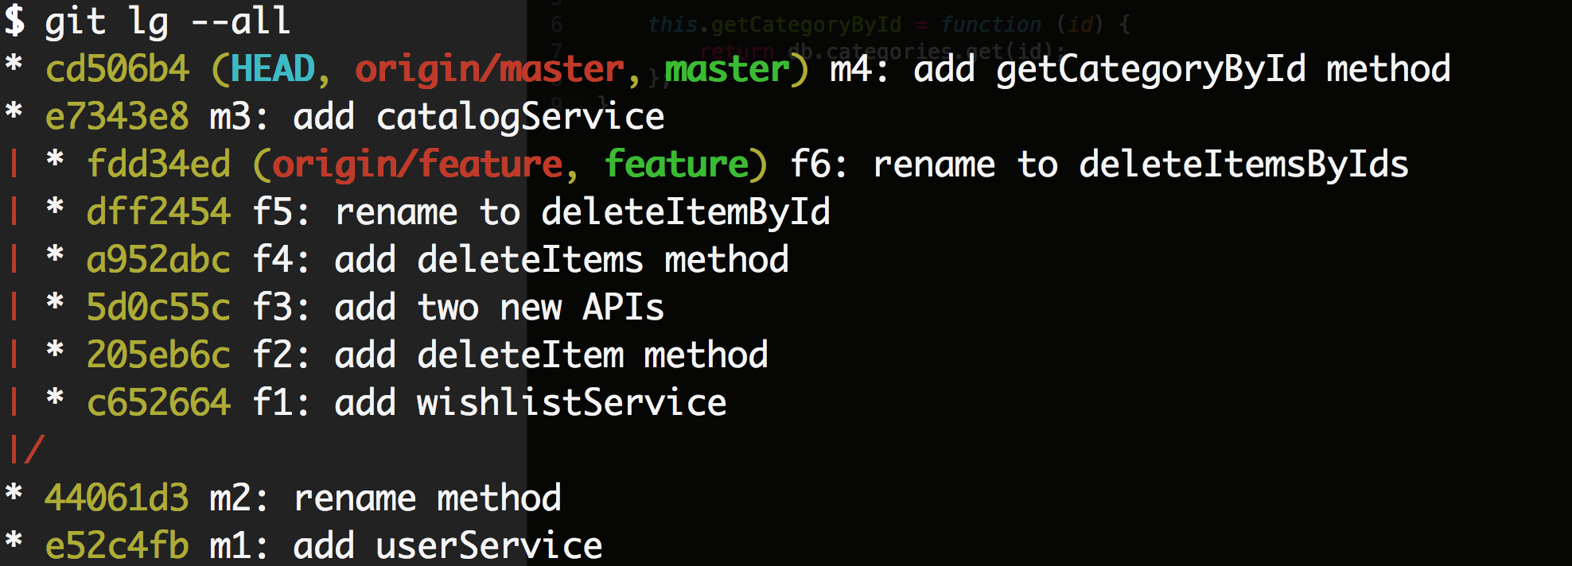

Now the first thing we want to do is to checkout our feature branch with git checkout feature. To get started with the rebase we run git rebase -i master.

Now what follows is that git opens a temporary file in the configured editor (defaults to Vim).

**Sol:**

* Fork the repository
* Clone into local repository

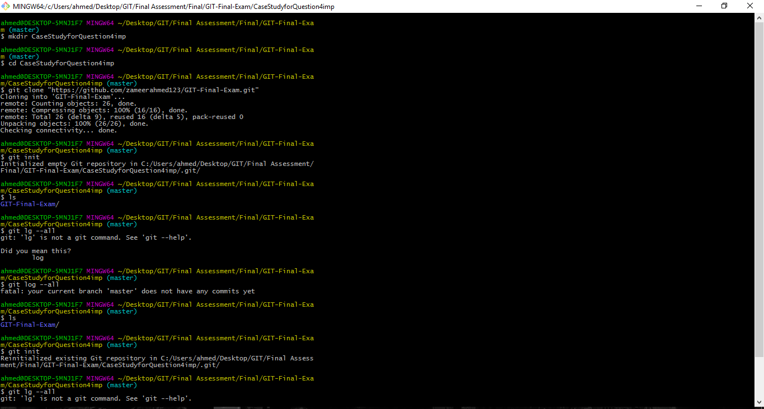

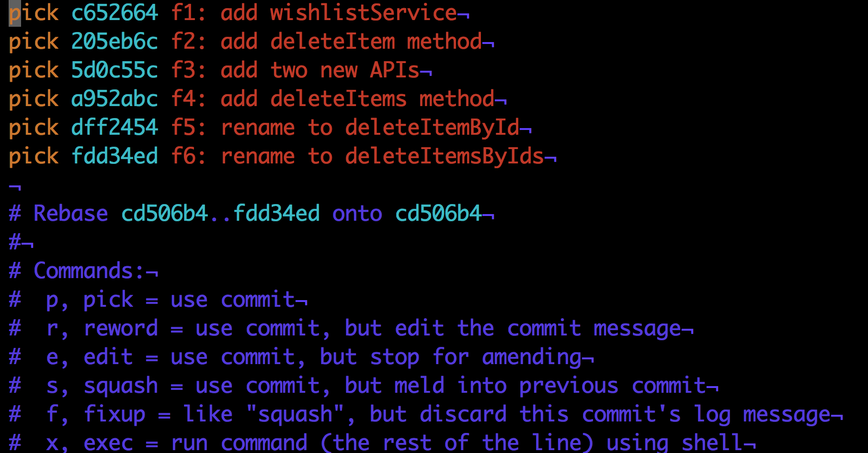

This file is meant to provide you some options for the rebase and it comes with a little cheat sheet (the blue text). For each commit we could choose between the actions pick, reword, edit, squash, fixup and exec. Each action can also be referred to by its short form p, r, e, s, f and e. It’s out of the scope of this article to describe each and every option so let’s focus on our specific task.

We want to choose the edit option for our f3 commit hence we change the contents to look like that.

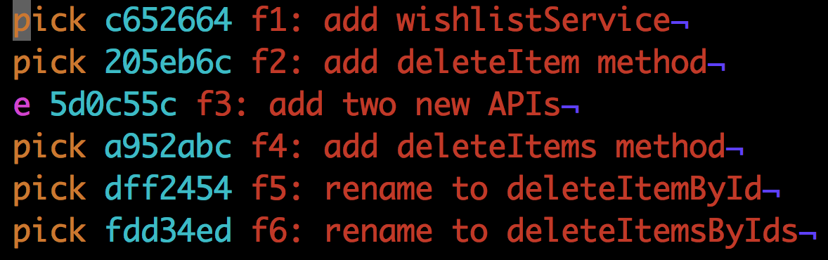

Now we save the file (in Vim <ESC> followed by :wq, followed by <RETURN>). The next thing we notice is that git stops the rebase at the commit for which we choose the edit option.

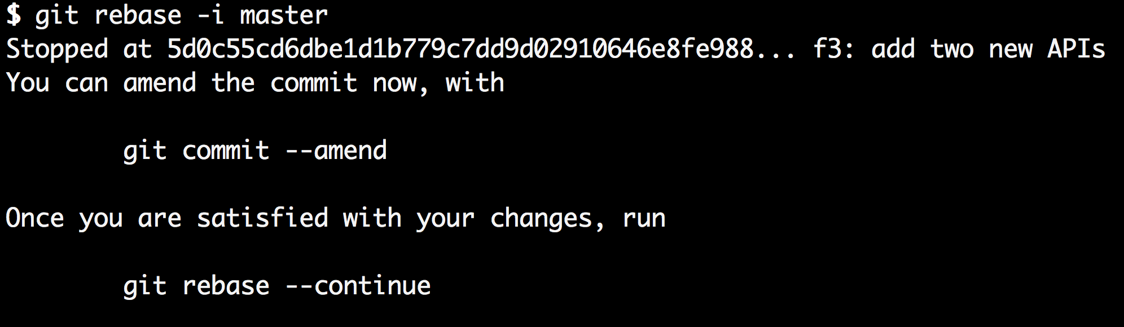

What this means is that git started to apply f1, f2 and f3 as if it was a regular rebase but then stopped **after** applying f3. In fact, we can prove that if we just look at the log at the point where we stopped.

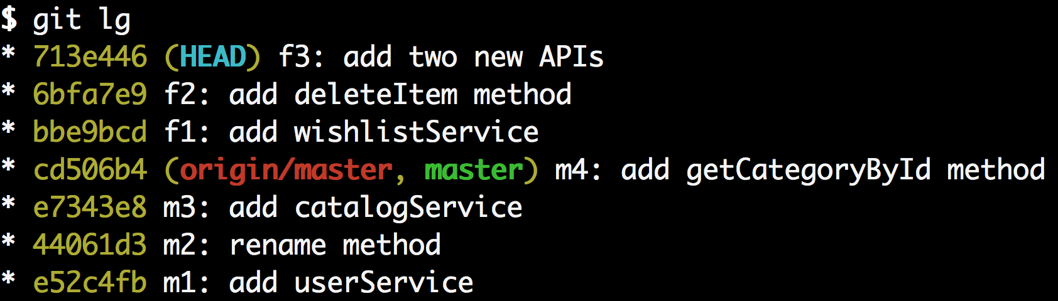

To split our commit f3 into two commits, all we have to do at this point is to reset gits pointer to the previous commit (f2) while keeping the working directory the same as it is right now. This is exactly what the mixed mode of git reset does. Since mixed is the default mode of git reset we can just write git reset head~1. Let’s do that and also run git status right after it to see what happened.

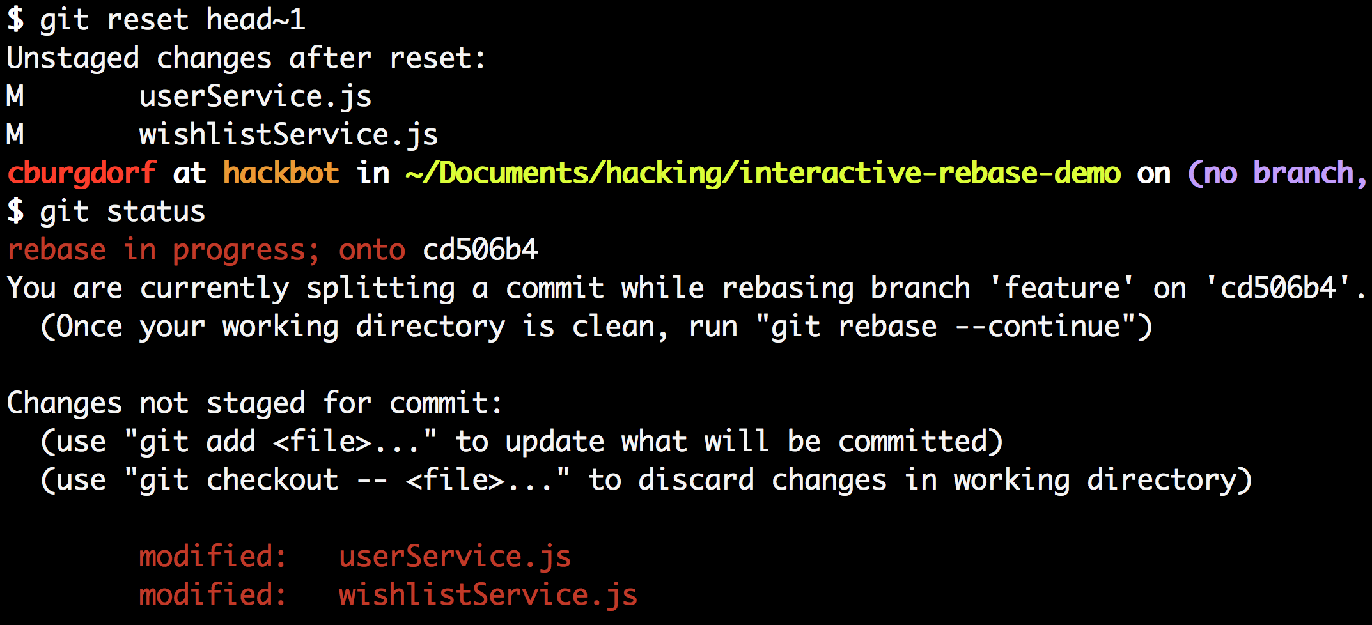

The git status tells us that both our userService.js and our wishlistService.js are modified. If we run git diff we can see that those are exactly the changes of our f3 commit.

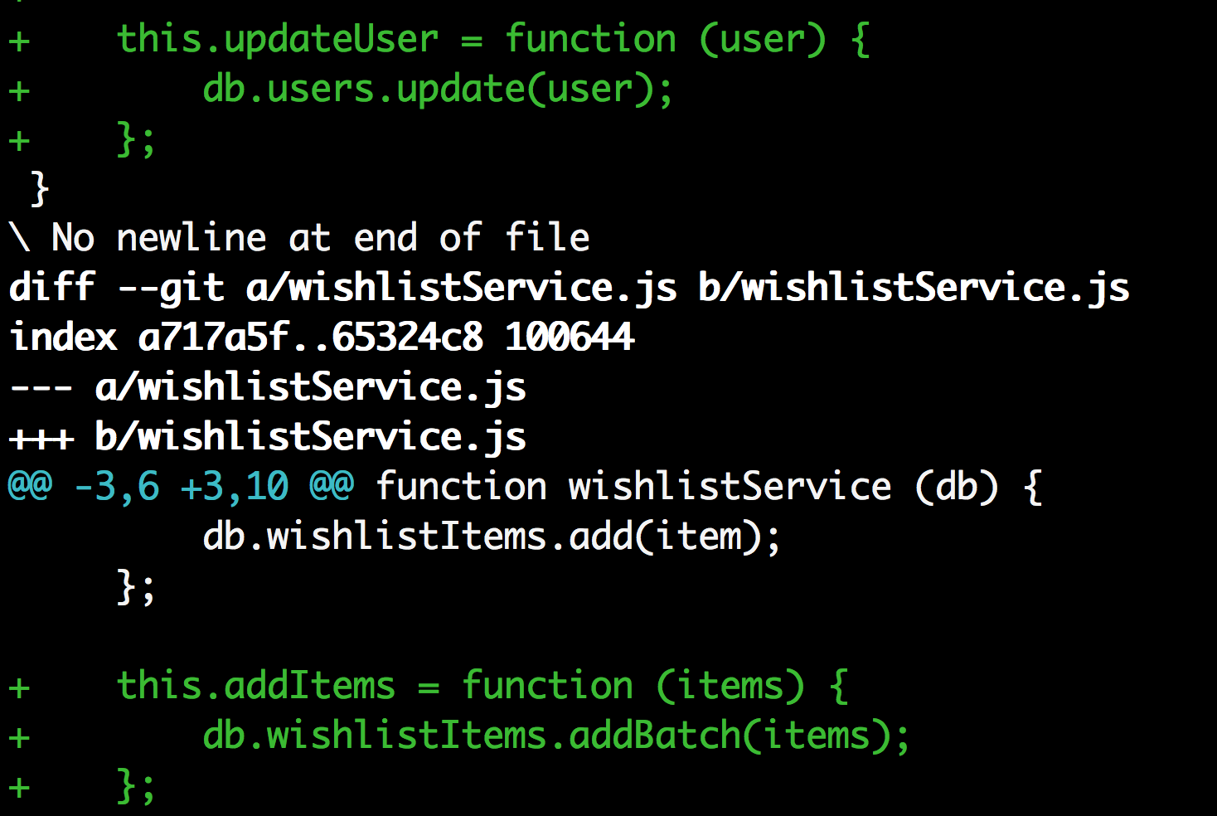



If we look at the log again at this point we see that the f3 is gone though.

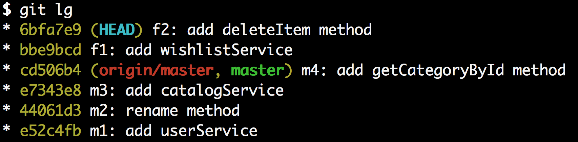

We are now at the point that we have the changes of our previous f3 commit ready to be committed whereas the original f3 commit itself is gone. Keep in mind though that we are still in the middle of a rebase. Our f4, f5 and f6 commits are not lost, they’ll be back in a moment.

Let’s make two new commits: Let’s start with the commit for the changes made to the userService.js which are fine to get picked into master. Run git add userService.js followed by git commit -m "f3a: add updateUser method".

Great! Let’s create another commit for the changes made to wishlistService.js. Run git add wishlistService.js followed by git commit -m "f3b: add addItems method".

Let’s take a look at the log again.

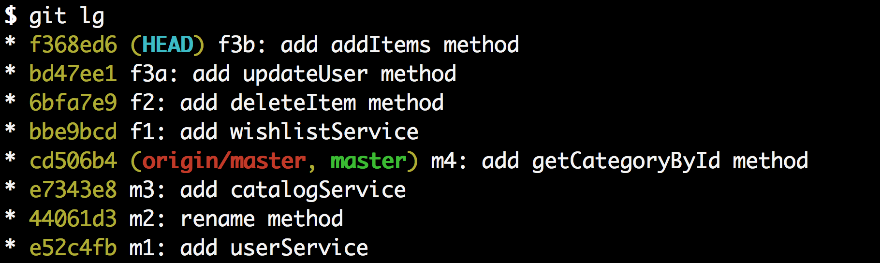

This is exactly what we wanted except our commits f4, f5 and f6 are still missing. This is because we are still in the middle of the interactive rebase and we need to tell git to continue with the rebase. This is done with the command git rebase --continue.

Let’s check out the log again.

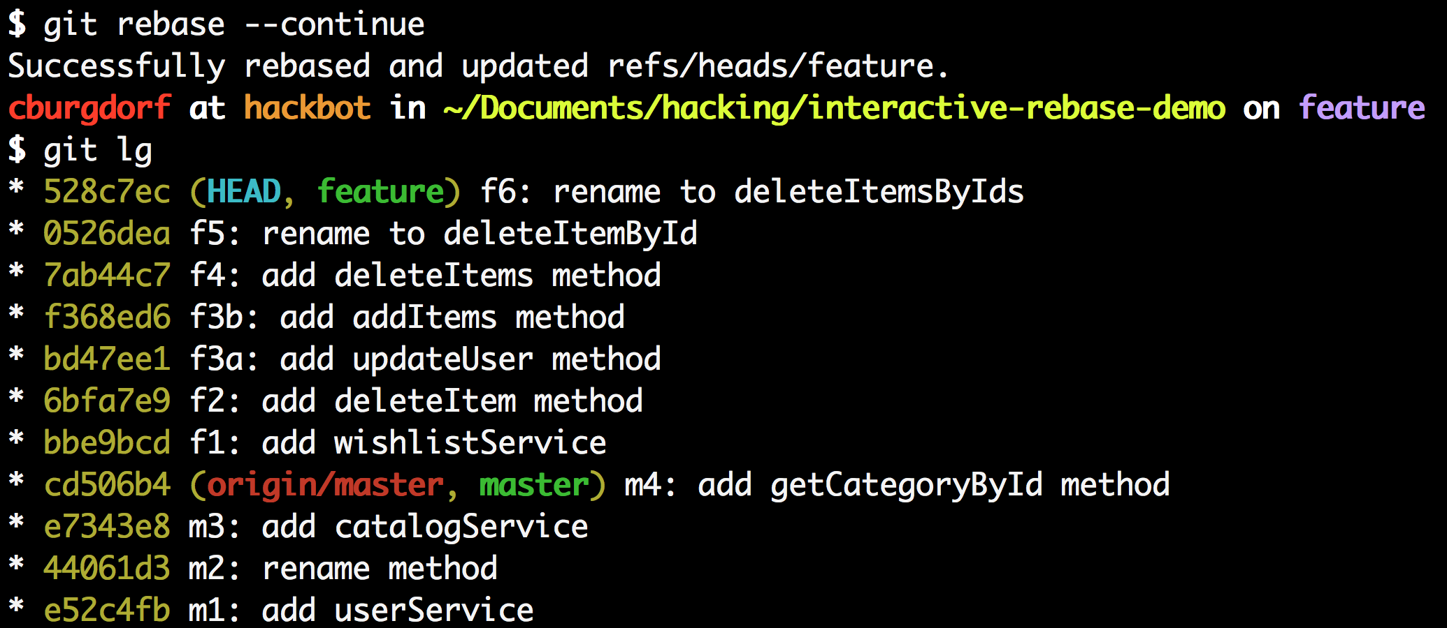

And that’s it. We now have the history we wanted. The previous f3 commit is now split into two commits f3a and f3b. The only thing left to do is to cherry-pick the f3a commit over to the master branch.

To finish the last step we first switch to the master branch. We do this with git checkout master. Now we can pick the f3a commit with the cherry-pick command. We can refer to the commit by its SHA key which is bd47ee1 in this case.

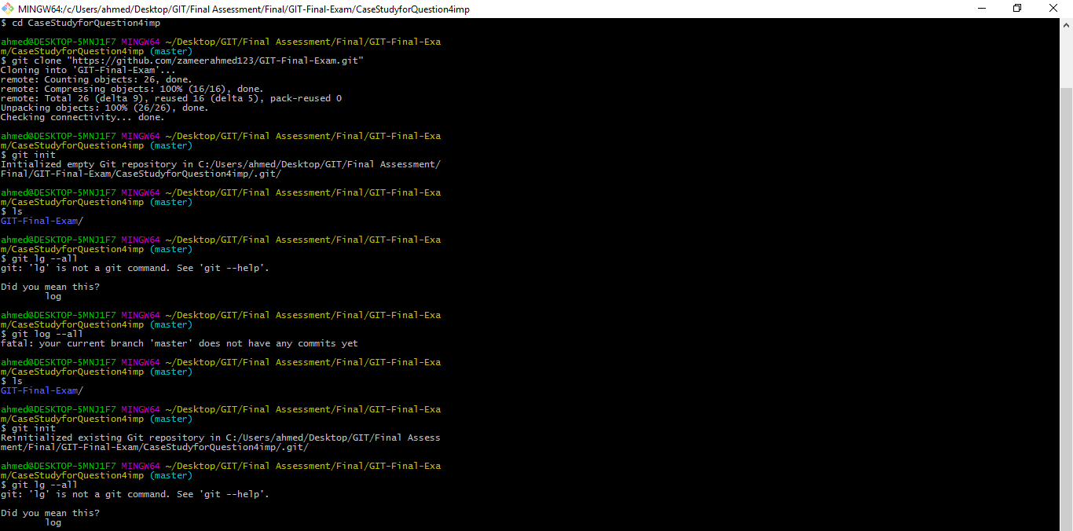

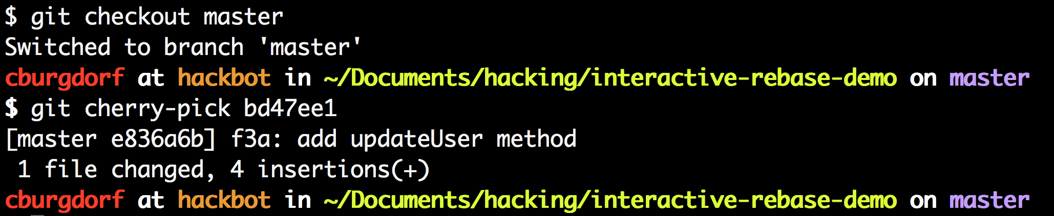

We now have the f3a commit sitting on top of latest master. Exactly what we wanted!



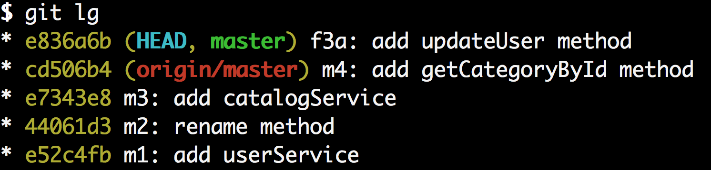

Given the length of the post this may seem like a lot of effort but it’s really only a matter of seconds for an advanced git user.

1. **Read the following case and explain the scenario at play at Electric Imp, problem at hand and solution being pursued. Give your opinion on how it can be done better per your understand. Also explain this git workflow methodology.**

**A Git workflow at EI**

Electric Imp have used Git from the very beginning of the company, and in that time we’ve evolved what I at least reckon is a useful way of using it, a useful workflow.

It’s ended up similar to, but not quite the same as, Vincent Driessen’s “Gitflow” model, and this blog post purposely uses similar diagrams, terminology, and colour-coding to that one, to make comparisons easier (though hopefully it also stands alone, for those who haven’t read it).

**The big picture**

There’s a single central Git repository, origin, from which all releases are made and in which all tags reside. Because Git is “decentralised”, each developer has one or more local repositories too.

This diagram, like Vincent Driessen’s original, is drawn with *oldest at the top, newest at the bottom*, which is the opposite of the convention used by gitk.

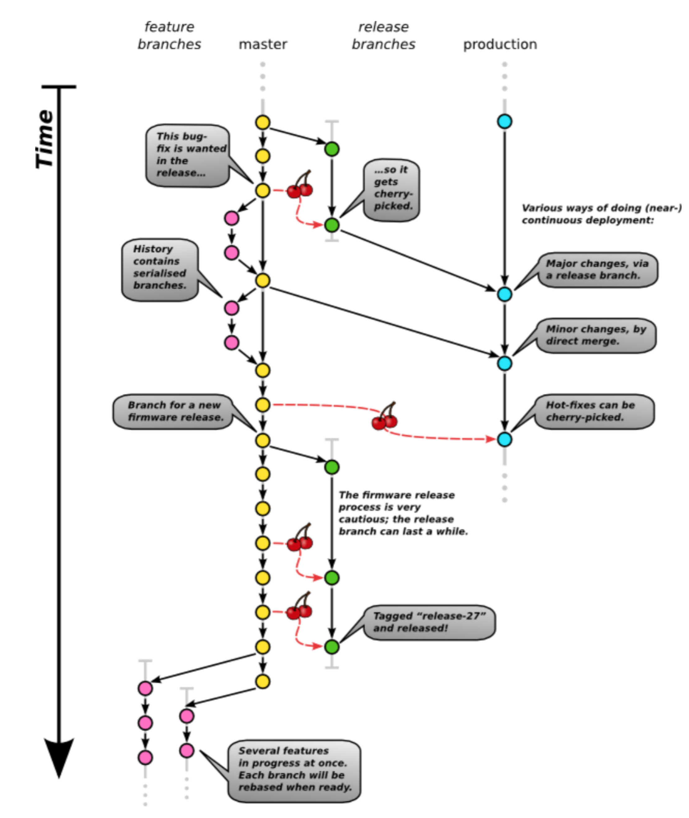

**Quick summary of differences from “Gitflow”**

The yellow (main, integration) branch is, for historical reasons, called master;

The blue (deployment) branch is called production; Bug-fixes are cherry-picked out from yellow to release branches wherever possible, rather than being merged from release branches back to yellow; Pink feature branches (those done by single individuals, at least) are done as bow-shaped merges; Because of the bow-shaped merges, yellow is never *merged* out to feature branches: if a feature branch needs some new stuff that’s landed on yellow, it gets *rebased* on top of yellow; Because we do two kinds of releases from the same codebase – server deployments which are lightweight and rapid, and client firmware upgrades which are more heavyweight and intrusive – there are two kinds of green release branch which are treated slightly differently. (But the server deployment one works much like the “Gitflow” equivalent.)

These are mostly fairly minor differences. (But notice how there are very few non- rebased merges.)

**The two long-lived branches and their relationship**

The integration branch (“master”, yellow) and the deployment branch (“production”, blue) are the only branches that continue to get new commits indefinitely.

All new work happens on master; work that consists of only one or two commits goes straight in, and work that’s more involved than that lands via the merging of a *feature branch*, of which more below.

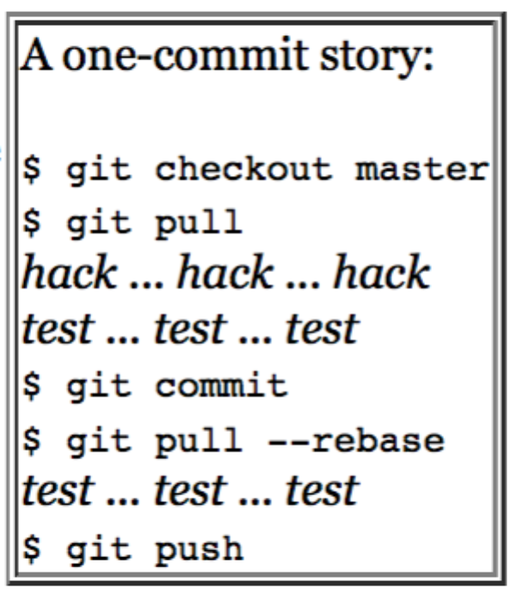

The Jenkins continuous-integration server runs whenever new commits are made to master: it builds the whole codebase for all relevant platforms, runs all the unit tests, runs all the integration tests, and finally runs some system-tests on a test farm of real hardware. The quality bar for pushes to master, is clean runs on all of these test suites; any failures are stop-the-line emergencies. If a build or tests is failing, the very next push must be the fix, or other developers can’t continue pushing (because they can’t know whether their own work passes that test or not). This is usually known as “do not commit on red” – although with Git, it’s actually the “push”, not “commit”, operation that’s the relevant one.

This achieves the goal that “There is a known production branch, so you don’t have to think. If you checkout the equivalent of production, it’s either exactly what’s currently in production or it’s what’s about to be in production.”

Also, “The production branch is known-good. It is *never* a mistake to push the production branch to production servers, ever.” This eases communication with the Operations team. New work is never done directly onto production: it arrives there due to either merges or cherry-picks from master (possibly via an intermediate release or hot-fix branch).

**Feature branches**

Feature branches are usually short-lived, and indeed usually exist as named branches only in developers’ local repositories. (With Git, if you merge a branch locally into master and then push the result, the branching *structure* is pushed to origin and becomes part of permanent history, but the branch *name* isn’t pushed, and doesn’t appear in the origin repository except perhaps in the commit comment of the merge.)

Feature branches are usually named with the developer’s initials and a brief hint to the branch’s purpose: for instance, pdh-regexp was my branch for implementing a regular-expressions feature.

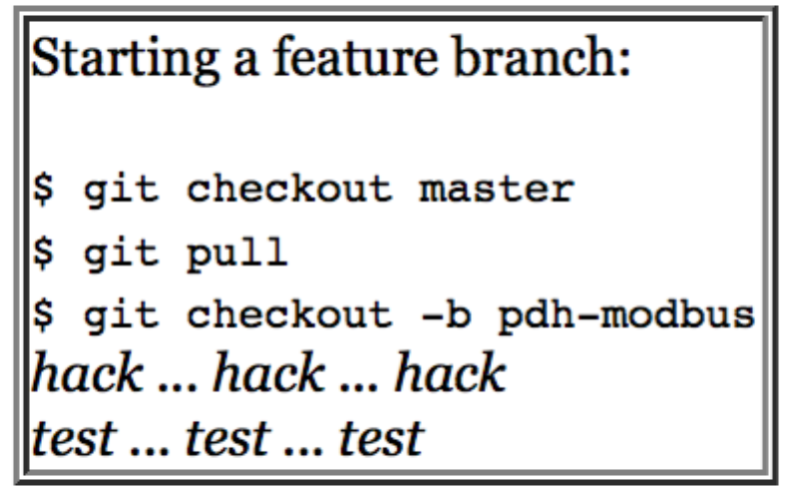

There are two exceptions to the above description, both (hopefully) pretty rare: the first is that, if a feature branch is getting so big or so long-lived that it could do with living on the origin server too purely as a backup strategy, then its developer can push it to origin. Prefixing the name with the initials, though, makes clear that it’s a private branch, in the sense that it is likely to get forcibly rebased by that developer, so *caveat emptor*.

The second exception is when several developers are working on the same feature. This is also probably relatively rare (Kanban and Agile encourage single- developer, or single-pair, working), but it doesn’t fit the same model, because a branch that gets commits from two different sources, can’t be rebased without messing up the other developers. So in that situation, you’d keep the feature branch on origin, the co-operating developers would pull it using git pull -- rebase and push it using git push. Once the feature is reviewed, QA’d, and delivered, the collaborative feature branch can be merged to master. *This is the only situation in which a non-rebased branch gets merged to master*. (“Gitflow” also suggests the use of developer-to-developer, not developer-to-origin, Git pulls and pushes for managing this case, but that sounds to me like a recipe for confusion, plus it’s hard to do with a rebase workflow.)

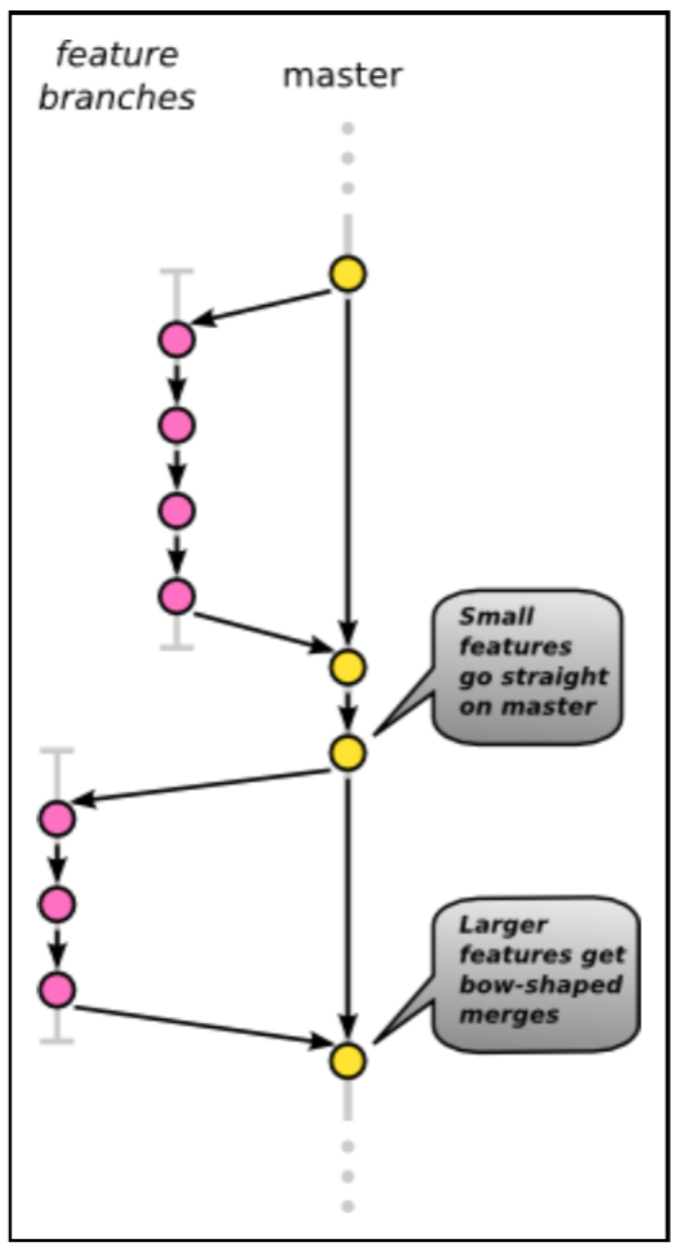

**Two different release patterns**

Electric Imp has a single repository from which all parts of the system are built: this eases system testing, and the addition of system-wide features, but it does mean that two different types or cadences of “release” happen from the same codebase.

*Server releases* are deployed to our cloud service. As is best-practice in the server software culture, this is (close to) continuous deployment. Releases are made really quite often, sometimes several times per day – so often, in fact, that it’s pointless even to tag or number them (we’d be in the hundreds). This is achievable because it’s relatively easy for automated testing to cover the entire gamut of server functionality, because upgrades themselves and reverts or hot-fixes are so straightforward as to be virtually push-button, and because (assuming the revert script works as-tested) the impact of a “bad” release is relatively minor. The pace of server releases demands a lightweight release process.

None of those considerations apply to *client firmware releases*: covering the gamut of firmware functionality can require custom hardware, upgrades get downloaded over the Internet and programmed into flash memory (which is a bit disruptive and can be time-consuming) – and, in theory at least, a “bad” release could be quite awkward to recover from (requiring careful actions by individual end-users). So firmware releases are performed with considerably more caution: the QA, beta-test, and qualification process for a newly-made release branch typically takes a number of *weeks*. This is (by our standards at least) a heavyweight release process.

Another important difference is that the end-user can at any time get bored of the device, put it away in a drawer for an arbitrary length of time, then rekindle their interest, retrieve the device, and try to use it. This means that the *current* server release must work with *all* previous client releases (at least enough for them to upgrade themselves), a criterion fortunately not present in the reverse direction. This concern makes it worth our while keeping the total number of client releases down (and getting cross when “beta” or “test” releases go out without being tagged).

**The heavyweight release process**

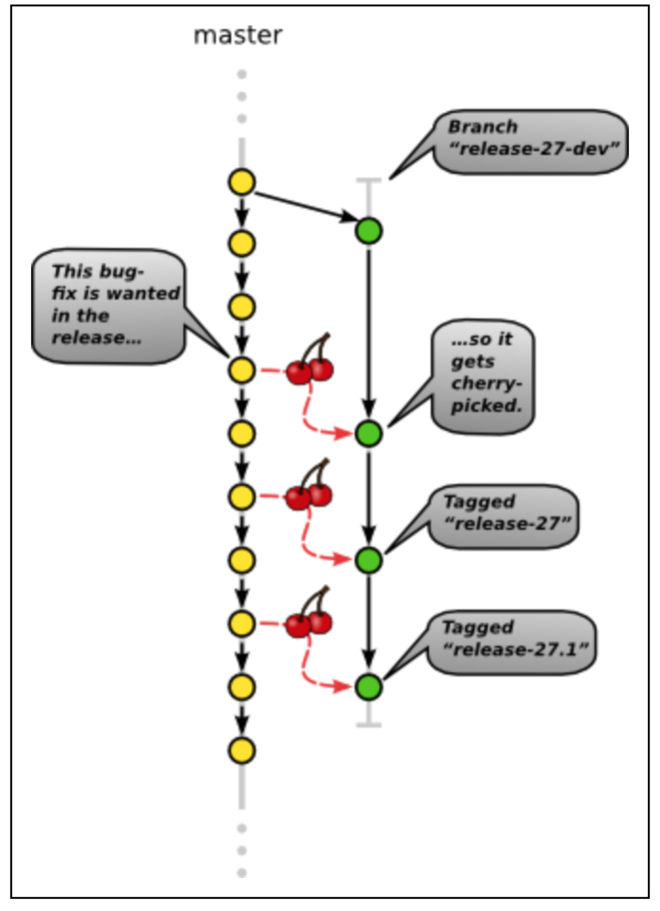

The heavyweight release process, which we use for firmware releases, is based mainly on an abundance of caution.

Once the required collection of new functionality has landed on master, a new release branch is made. This is named after the first release that’s expected to be made from the branch: every release is numbered, with (for instance) releases 25, 25.1, and 25.2 all coming from the release-25-dev branch.

Once the branch is made, it is subjected to the unblinking eye of QA – even a culture of good unit-tests, integration tests, and system tests does not rule out the need for exploratory testing before release.

For major new functionality there may even be a closed beta process, where end-users hand-picked for both eagerness and cluefulness get given tagged beta releases from the branch to supplement our internal testing.

Once a release branch is made, the only subsequent changes are bug fixes. If and when issues are found on a release branch, we adopt GCC’s rule that fixes must (wherever possible) be made on master first and then cherry-picked out to the release branch. This is what ensures that the fix will also end up in *subsequent* releases: unlike in “Gitflow”, the release branch is not merged back to master.

And if (horrors!) an issue should crop up in a the release after is tagged and rolled out, it again gets fixed on master first and cherry-picked out to the release branch. A point release gets tagged and rolled out: release-27.1, say.

Only if master has moved on so much in the meantime, that the fix for master doesn’t apply on the branch, would fixing take place directly on the release branch.

**The lightweight release process**

The lightweight release process, which we use for server releases, is based on responding with alacrity to new requirements or to current events – for instance, unexpected load on the servers might require new logging or instrumentation to be added basically immediately.

Releases are made so often that they don’t even get names (and nobody would remember or use them if they did). So to indicate the current state of the production servers, a deployment branch is used. (This is the same as the “blue branch” of “Gitflow”, except that we call it production rather than master.) It’s also the case that, because when we upgrade the server everyone gets it straightaway, previous versions are dead and gone: they don’t hang around in the way that previous firmware releases do. To a much larger extent than with firmware, at any given time only the most recent release matters at all.

As for updating production: if major replumbing or massive new functionality has landed in the server code, it might sometimes be useful to use the heavyweight process – except, with the success event being merging out to production rather than tagging and releasing. More often, though, the necessary alacrity is achieved by a reduced process: picking a suitable version of master, testing it (perhaps by deploying it to staging servers), applying fixes directly to master where necessary, and then simply merging out to production and pushing.

Hot-fixes, small patches to the production code done for emergency situations, can be written on master, cherry-picked *locally* into production, passed by code-reviewers and/or QA, and then pushed to origin/production. (In “Gitflow”, hot-fixes are landed via a short-lived hot-fix branch. That would be useful where a hot-fix itself consists of a *series* of commits, not just one – but that seems like it would rarely actually happen.)

**Scaling out to enormous development organisations**

All of the above assumes that the development organisation is small enough to operate as a single team. Above a certain size, this starts to become awkward: even the rare bad commits on master start to happen too often, and the ([lock-free but not wait-free](http://en.wikipedia.org/wiki/Non-blocking_algorithm)) bow-shaped merge process starts to become a bottle-neck.

In this situation, all you can do is introduce more process (and hope that the increase in developer numbers offsets the decrease in per-developer productivity – an outcome far from guaranteed). What you end up doing is dividing into teams and running the heavyweight release process – but, instead of releasing directly, releasing to an internal “meta-integration” branch where the “best available” versions of each team’s work are combined, to then face further automated and manual testing before actual release.

Really enormous organisations would end up with meta-meta-integration branches, or worse. Releases become great tides that ripple through the organisation, to be taken at the flood or omitted as necessary: the magic phrase to Google for to read more about Agile-in-the-large seems to be “release train”...

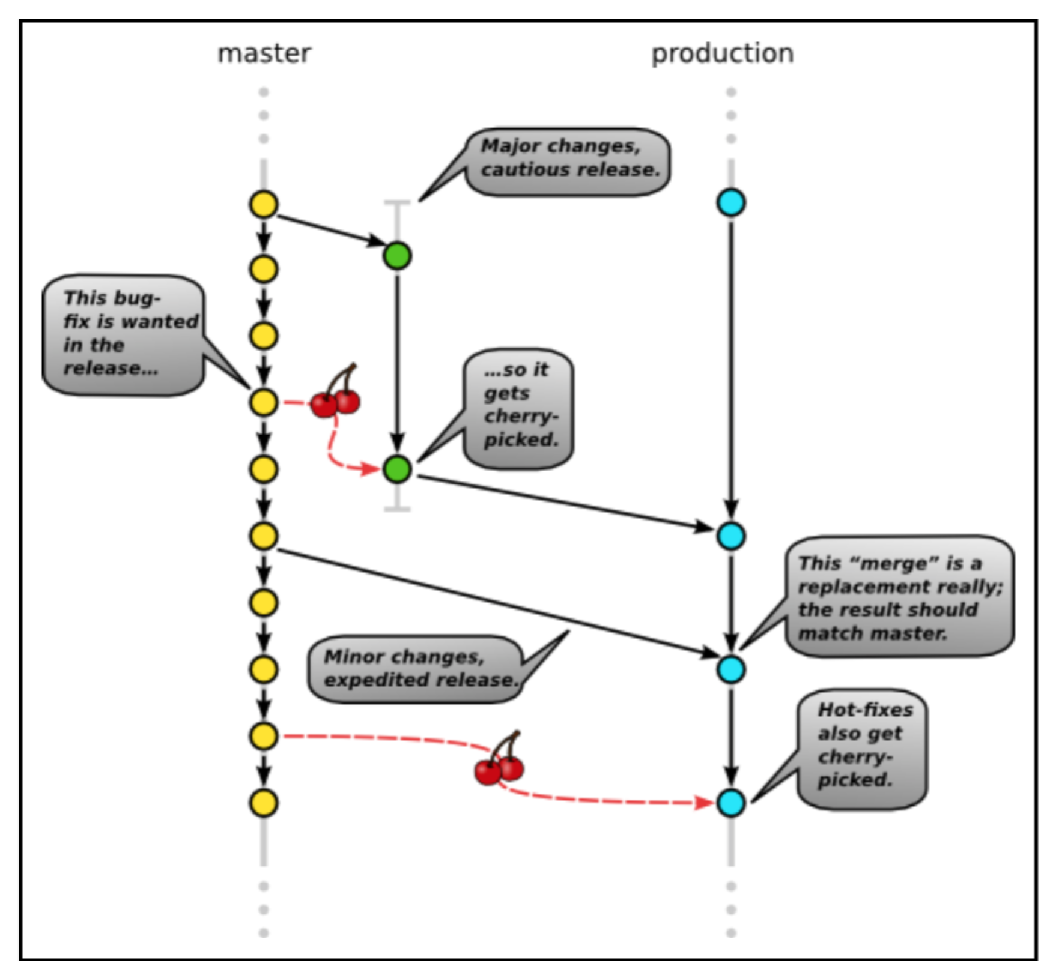

**Sol:**

The main branches ¶

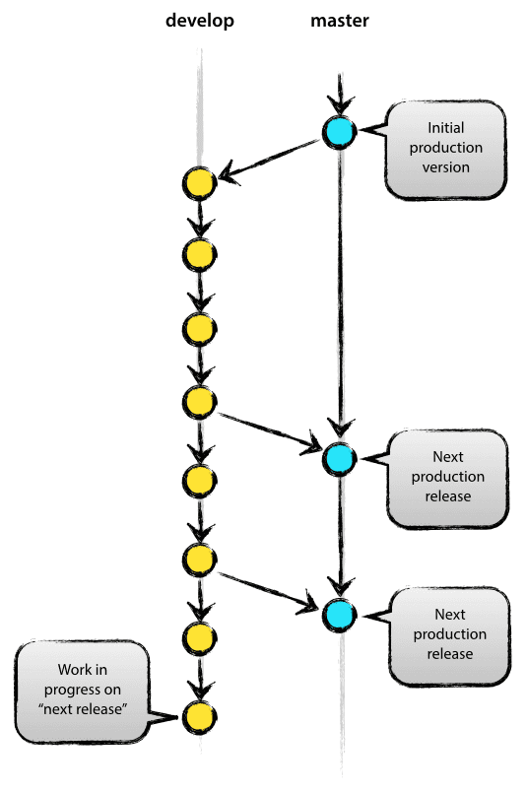

At the core, the development model is greatly inspired by existing models out there. The central repo holds two main branches with an infinite lifetime:

master

develop

The master branch at origin should be familiar to every Git user. Parallel to the master branch, another branch exists called develop.

We consider origin/master to be the main branch where the source code of HEAD always reflects a production-ready state.

We consider origin/develop to be the main branch where the source code of HEAD always reflects a state with the latest delivered development changes for the next release. Some would call this the “integration branch”. This is where any automatic nightly builds are built from.

When the source code in the develop branch reaches a stable point and is ready to be released, all of the changes should be merged back into master somehow and then tagged with a release number. How this is done in detail will be discussed further on.

Therefore, each time when changes are merged back into master, this is a new production release by definition. We tend to be very strict at this, so that theoretically, we could use a Git hook script to automatically build and roll-out our software to our production servers everytime there was a commit on master.

Supporting branches ¶

Next to the main branches master and develop, our development model uses a variety of supporting branches to aid parallel development between team members, ease tracking of features, prepare for production releases and to assist in quickly fixing live production problems. Unlike the main branches, these branches always have a limited life time, since they will be removed eventually.

The different types of branches we may use are:

Feature branches

Release branches

Hotfix branches

Each of these branches have a specific purpose and are bound to strict rules as to which branches may be their originating branch and which branches must be their merge targets. We will walk through them in a minute.

By no means are these branches “special” from a technical perspective. The branch types are categorized by how we use them. They are of course plain old Git branches.

Feature branches ¶

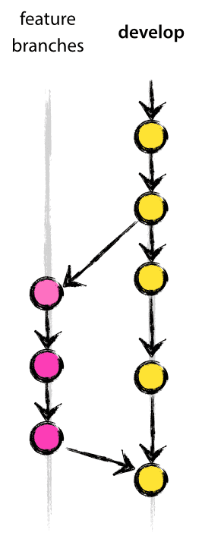

May branch off from:

develop

Must merge back into:

develop

Branch naming convention:

anything except master, develop, release-*, or hotfix-*

Feature branches (or sometimes called topic branches) are used to develop new features for the upcoming or a distant future release. When starting development of a feature, the target release in which this feature will be incorporated may well be unknown at that point. The essence of a feature branch is that it exists as long as the feature is in development, but will eventually be merged back into develop (to definitely add the new feature to the upcoming release) or discarded (in case of a disappointing experiment).

Feature branches typically exist in developer repos only, not in origin.

Creating a feature branch ¶

When starting work on a new feature, branch off from the develop branch.

$ git checkout -b myfeature develop

Switched to a new branch "myfeature"

Incorporating a finished feature on develop ¶

Finished features may be merged into the develop branch to definitely add them to the upcoming release:

$ git checkout develop

Switched to branch 'develop'

$ git merge --no-ff myfeature

Updating ea1b82a..05e9557

(Summary of changes)

$ git branch -d myfeature

Deleted branch myfeature (was 05e9557).

$ git push origin develop

The --no-ff flag causes the merge to always create a new commit object, even if the merge could be performed with a fast-forward. This avoids losing information about the historical existence of a feature branch and groups together all commits that together added the feature. Compare:

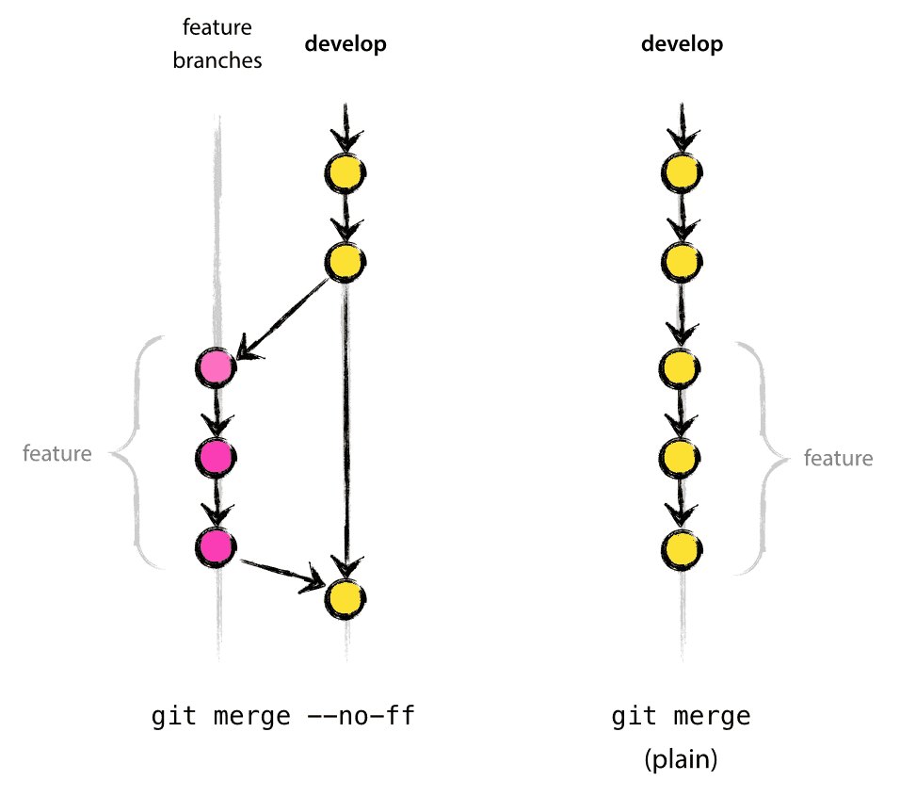

In the latter case, it is impossible to see from the Git history which of the commit objects together have implemented a feature—you would have to manually read all the log messages. Reverting a whole feature (i.e. a group of commits), is a true headache in the latter situation, whereas it is easily done if the --no-ff flag was used.

Yes, it will create a few more (empty) commit objects, but the gain is much bigger than the cost.

Release branches ¶

May branch off from:

develop

Must merge back into:

develop and master

Branch naming convention:

release-*

Release branches support preparation of a new production release. They allow for last-minute dotting of i’s and crossing t’s. Furthermore, they allow for minor bug fixes and preparing meta-data for a release (version number, build dates, etc.). By doing all of this work on a release branch, the develop branch is cleared to receive features for the next big release.

The key moment to branch off a new release branch from develop is when develop (almost) reflects the desired state of the new release. At least all features that are targeted for the release-to-be-built must be merged in to develop at this point in time. All features targeted at future releases may not—they must wait until after the release branch is branched off.

It is exactly at the start of a release branch that the upcoming release gets assigned a version number—not any earlier. Up until that moment, the develop branch reflected changes for the “next release”, but it is unclear whether that “next release” will eventually become 0.3 or 1.0, until the release branch is started. That decision is made on the start of the release branch and is carried out by the project’s rules on version number bumping.

Creating a release branch ¶

Release branches are created from the develop branch. For example, say version 1.1.5 is the current production release and we have a big release coming up. The state of develop is ready for the “next release” and we have decided that this will become version 1.2 (rather than 1.1.6 or 2.0). So we branch off and give the release branch a name reflecting the new version number:

$ git checkout -b release-1.2 develop

Switched to a new branch "release-1.2"

$ ./bump-version.sh 1.2

Files modified successfully, version bumped to 1.2.

$ git commit -a -m "Bumped version number to 1.2"

[release-1.2 74d9424] Bumped version number to 1.2

1 files changed, 1 insertions(+), 1 deletions(-)

After creating a new branch and switching to it, we bump the version number. Here, bump-version.sh is a fictional shell script that changes some files in the working copy to reflect the new version. (This can of course be a manual change—the point being that some files change.) Then, the bumped version number is committed.

This new branch may exist there for a while, until the release may be rolled out definitely. During that time, bug fixes may be applied in this branch (rather than on the develop branch). Adding large new features here is strictly prohibited. They must be merged into develop, and therefore, wait for the next big release.

Finishing a release branch ¶

When the state of the release branch is ready to become a real release, some actions need to be carried out. First, the release branch is merged into master (since every commit on master is a new release by definition, remember). Next, that commit on master must be tagged for easy future reference to this historical version. Finally, the changes made on the release branch need to be merged back into develop, so that future releases also contain these bug fixes.

The first two steps in Git:

$ git checkout master

Switched to branch 'master'

$ git merge --no-ff release-1.2

Merge made by recursive.

(Summary of changes)

$ git tag -a 1.2

The release is now done, and tagged for future reference.

Edit: You might as well want to use the -s or -u <key> flags to sign your tag cryptographically.

To keep the changes made in the release branch, we need to merge those back into develop, though. In Git:

$ git checkout develop

Switched to branch 'develop'

$ git merge --no-ff release-1.2

Merge made by recursive.

(Summary of changes)

This step may well lead to a merge conflict (probably even, since we have changed the version number). If so, fix it and commit.

Now we are really done and the release branch may be removed, since we don’t need it anymore:

$ git branch -d release-1.2

Deleted branch release-1.2 (was ff452fe).

Hotfix branches ¶

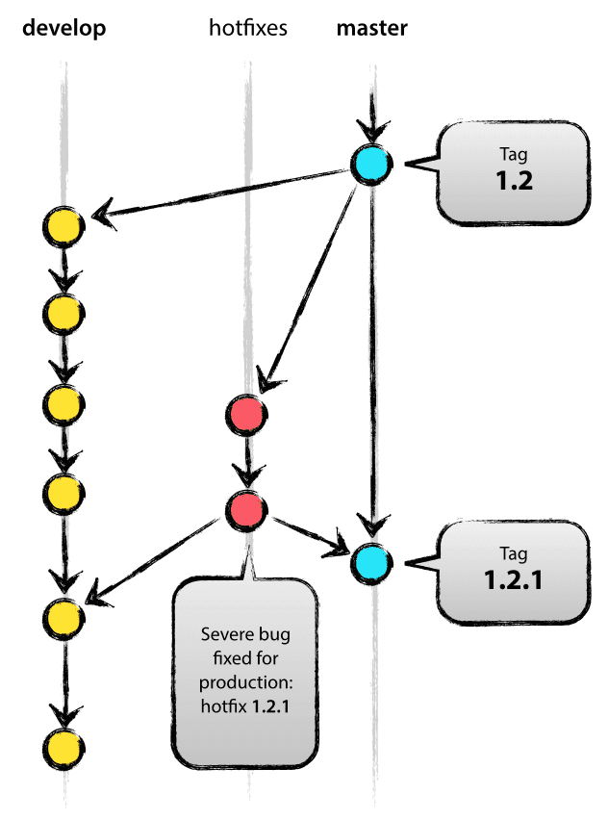

May branch off from:

master

Must merge back into:

develop and master

Branch naming convention:

hotfix-*

Hotfix branches are very much like release branches in that they are also meant to prepare for a new production release, albeit unplanned. They arise from the necessity to act immediately upon an undesired state of a live production version. When a critical bug in a production version must be resolved immediately, a hotfix branch may be branched off from the corresponding tag on the master branch that marks the production version.

The essence is that work of team members (on the develop branch) can continue, while another person is preparing a quick production fix.

Creating the hotfix branch ¶

Hotfix branches are created from the master branch. For example, say version 1.2 is the current production release running live and causing troubles due to a severe bug. But changes on develop are yet unstable. We may then branch off a hotfix branch and start fixing the problem:

$ git checkout -b hotfix-1.2.1 master

Switched to a new branch "hotfix-1.2.1"

$ ./bump-version.sh 1.2.1

Files modified successfully, version bumped to 1.2.1.

$ git commit -a -m "Bumped version number to 1.2.1"

[hotfix-1.2.1 41e61bb] Bumped version number to 1.2.1

1 files changed, 1 insertions(+), 1 deletions(-)

Don’t forget to bump the version number after branching off!

Then, fix the bug and commit the fix in one or more separate commits.

$ git commit -m "Fixed severe production problem"

[hotfix-1.2.1 abbe5d6] Fixed severe production problem

5 files changed, 32 insertions(+), 17 deletions(-)

Finishing a hotfix branch

When finished, the bugfix needs to be merged back into master, but also needs to be merged back into develop, in order to safeguard that the bugfix is included in the next release as well. This is completely similar to how release branches are finished.

First, update master and tag the release.

$ git checkout master

Switched to branch 'master'

$ git merge --no-ff hotfix-1.2.1

Merge made by recursive.

(Summary of changes)

$ git tag -a 1.2.1

Edit: You might as well want to use the -s or -u <key> flags to sign your tag cryptographically.

Next, include the bugfix in develop, too:

$ git checkout develop

Switched to branch 'develop'

$ git merge --no-ff hotfix-1.2.1

Merge made by recursive.

(Summary of changes)

The one exception to the rule here is that, when a release branch currently exists, the hotfix changes need to be merged into that release branch, instead of develop. Back-merging the bugfix into the release branch will eventually result in the bugfix being merged into develop too, when the release branch is finished. (If work in develop immediately requires this bugfix and cannot wait for the release branch to be finished, you may safely merge the bugfix into develop now already as well.)

Finally, remove the temporary branch:

$ git branch -d hotfix-1.2.1

Deleted branch hotfix-1.2.1 (was abbe5d6).

1. **Read this case and explain what you understand from this case. Explain the types of Integration feature branching types and explain why it is costly and unpredictable:**

**Version Control Strategies for continuous delivery**

*A taxonomy of version control strategies for and against Continuous Integration*

This series of articles describes a taxonomy for different types of Feature Branching – developers working on branches in isolation from trunk – and how Continuous Integration is impacted by Feature Branching variants.

1. Organisation Antipattern: Release Feature Branching – the what, why, and how of long-lived feature branches

2. Organisation Pattern: Trunk Based Development – the what, why, and how of trunk development

3. Organisation Antipattern: Integration Feature Branching – the what, why, and how of long-lived integration branches

4. Organisation Antipattern: Build Feature Branching – the what, why, and how of short-lived feature branches

*Integration Feature Branching is overly-costly and unpredictable*

Integration Feature Branching is a version control strategy where developers commit their changes to a shared remote branch of a source code repository prior to the shared trunk. Integration Feature Branching is applicable to both centralised Version Control Systems (VCS) and Distributed Version Control Systems (DVCS), with multiple variants of increasing complexity:

1. Type 1 – Integration branch and Trunk. This was originally used with VCSs such as [Subversion](https://subversion.apache.org/) and [TFS](https://www.visualstudio.com/en-us/products/tfs-overview-vs.aspx)
2. Type 2 – Feature branches, an Integration branch, and Trunk. This is used today with DVCSs such as [Git](https://www.git-scm.com/) and [Mercurial](https://mercurial.selenic.com/)
3. Type 3 – Feature release branches, feature branches, an Integration branch, and Trunk. This is advocated by [Git Flow](http://www.nvie.com/posts/a-successful-git-branching-model/)

In all Integration Feature Branching variants Trunk represents the latest production-ready state and Integration represents the latest completed changes ready for release. New features are developed on Integration (Type 1), or short-lived feature branches cut from Integration and merged back into Integration on completion (Types 2 and 3). When Integration contains a new feature it is merged into Trunk for release (Types 1 and 2), or a short-lived feature release branch cut from Integration and merged into Trunk and Integration on release (Type 3). When a production defect occurs it is fixed on a release branch cut from Trunk, then merged back to Integration (Types 1 and 2) or a feature release branch if one exists (Type 3).

Consider an organisation that provides an online Company Accounts Service, with its codebase maintained by a team practising Type 2 Integration Feature Branching. Initially two features are requested – F1 Computations and F2 Write Offs – so F1 and F2 feature branches are cut from Integration and developers commit their changes to F1 and F2.

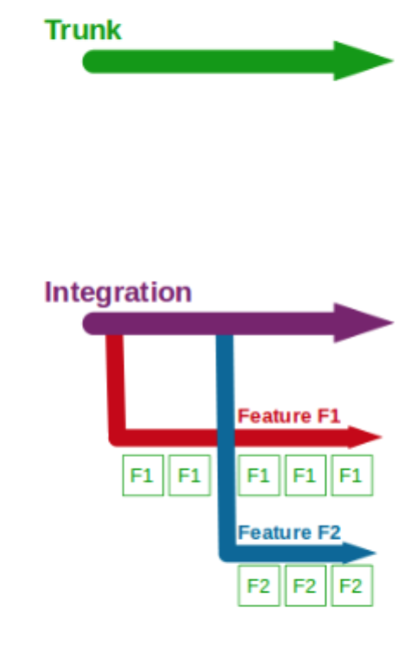

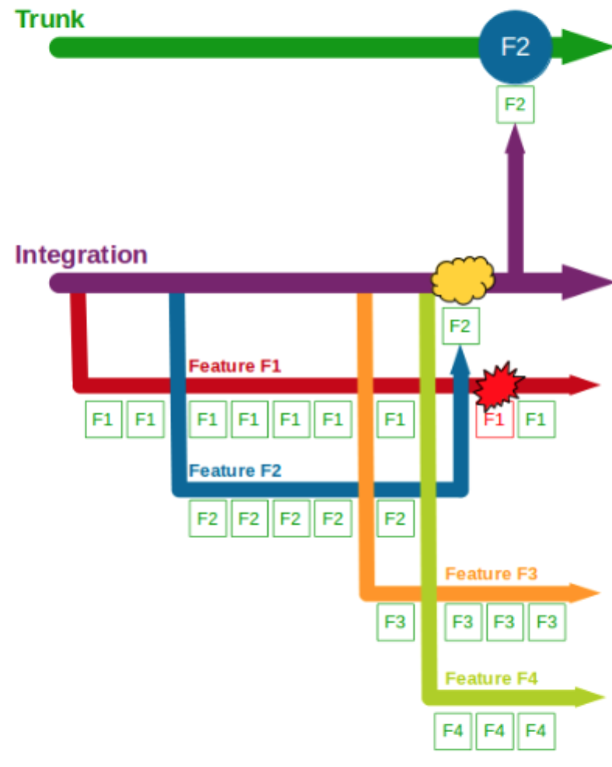

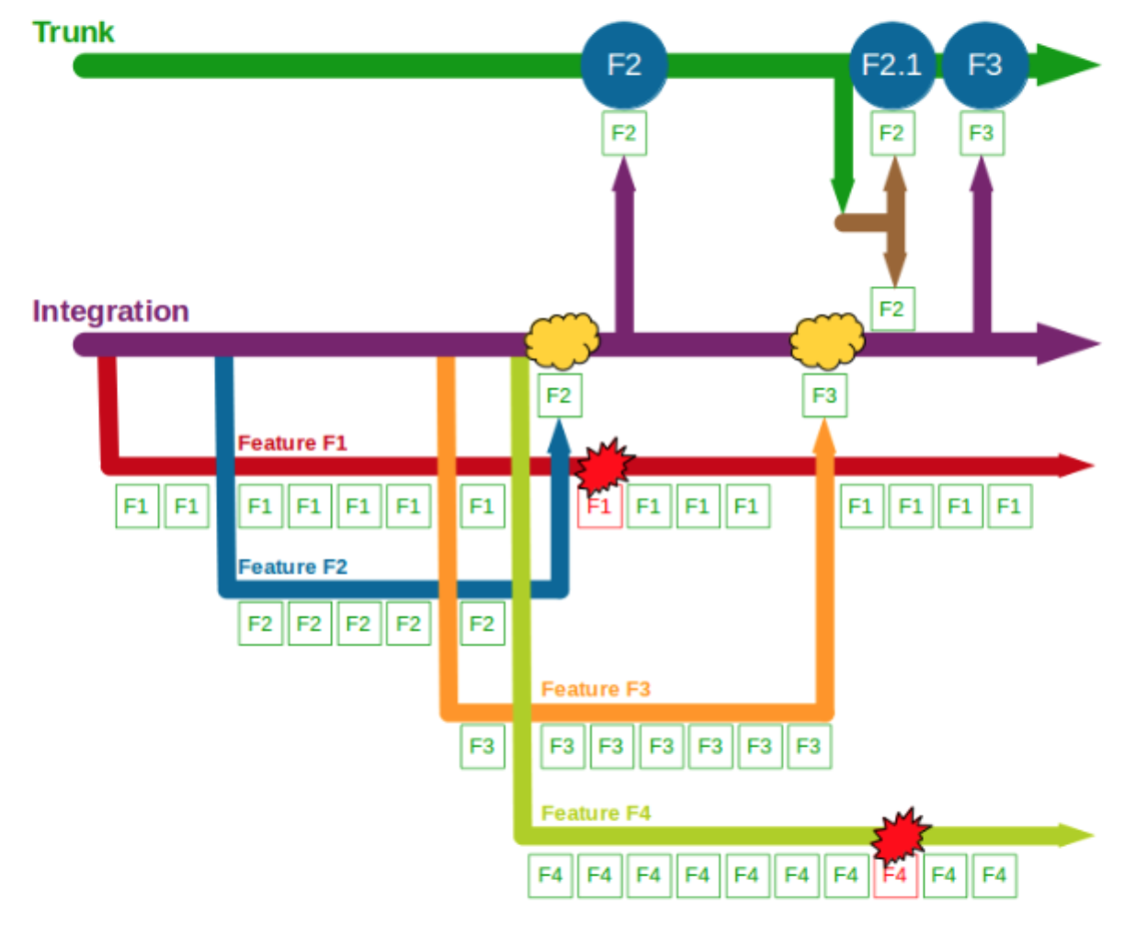

Two more features – F3 Bank Details and F4 Accounting Periods – then begin development, with F3 and F4 feature branches cut from Integration and developers committing to F3 and F4. F2 is completed and merged into Integration, and after testing it is merged into Trunk and regression tested before its production release. The F1 branch is briefly broken by a computations refactoring, with no impact on Integration.

When F3 is completed it is merged into Integration + F2 and tested, but in the meantime a production defect is found in F2. A F2.1 fix is made on a F2.1 release branch cut from Trunk + F2, and after its release F2.1 is merged into and regression tested on both Integration + F2 + F3 and Trunk + F2. F3 is then merged into Trunk and regression tested, after which it is released into production. F1 continues development, and the F4 branch is temporarily broken by changes to the submissions system.

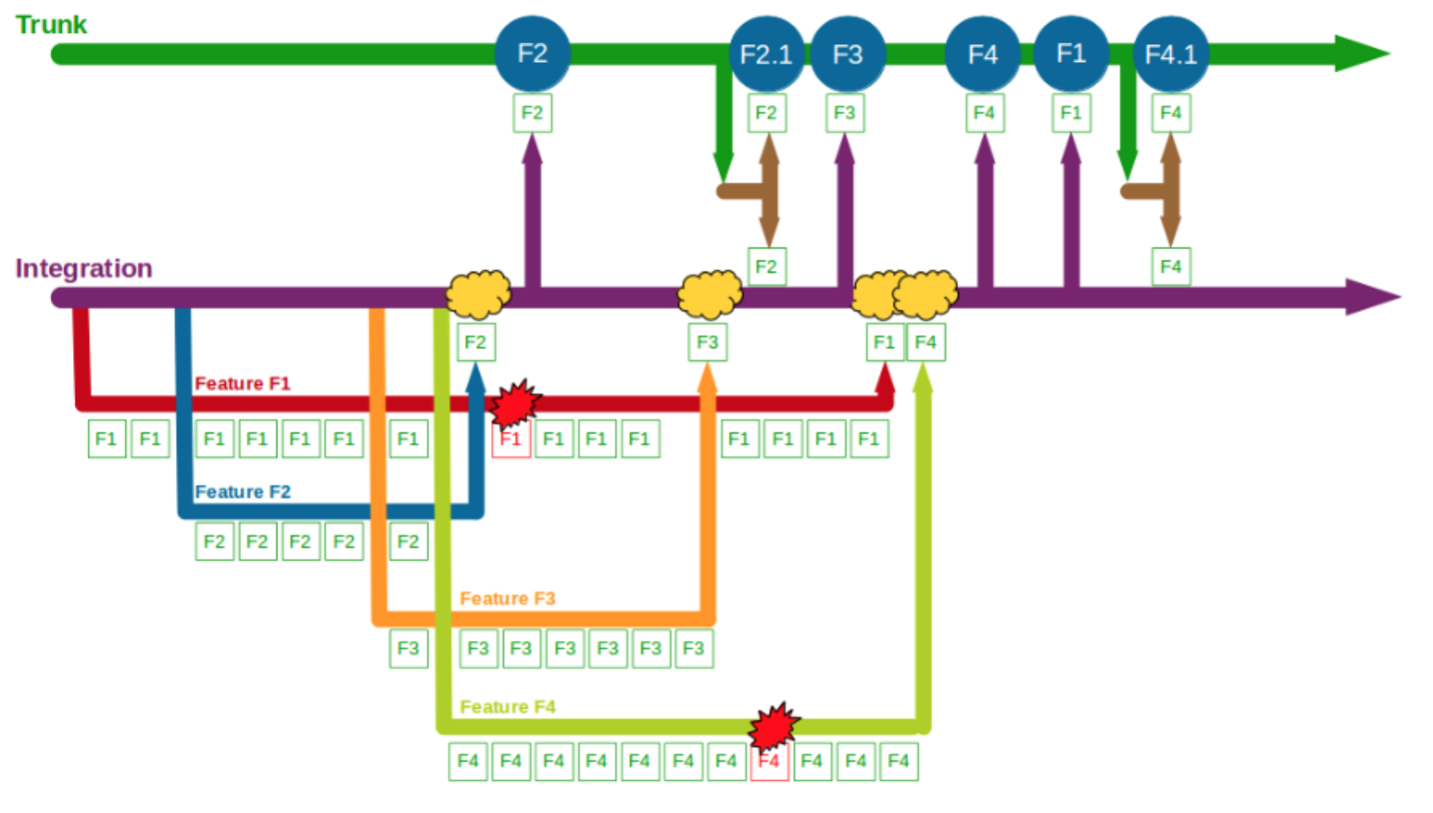

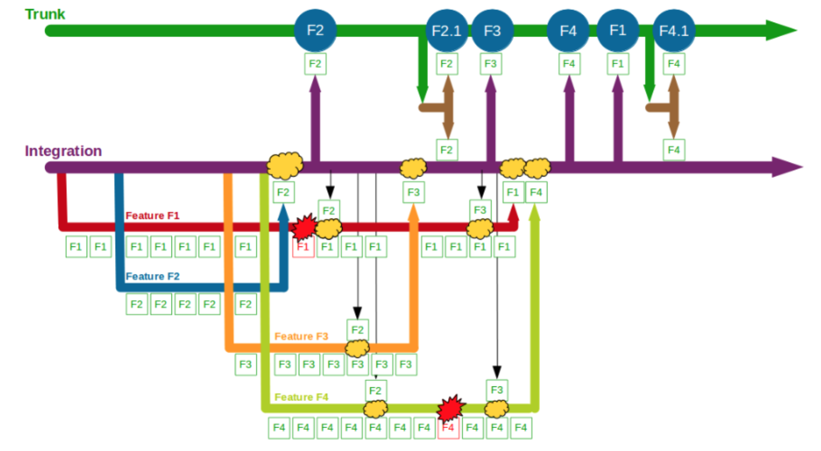

When F1 is completed and merged into Integration + F2 + F3 + F2.1 it is ready for production release, but a business decision is made to release F4 first. F4 is completed and after being merged into and tested on both Integration + F2 + F3 + F2.1 + F1 and Trunk + F2 + F3 + F2.1 it is released into production. Soon afterwards F1 is merged into and regression tested on Trunk + F2 + F2.1 + F3, then released into production. A production defect is found in F4, and a F4.1 fix is made on a release branch cut from Trunk + F2 + F2.1 + F3 + F4 + F1. Once F4.1 is released it is merged into and regression tested on both Integration + F2 + F3 + F2.1 + F1 + F4 and Trunk + F2 + F2.1 + F3 + F4 + F1.

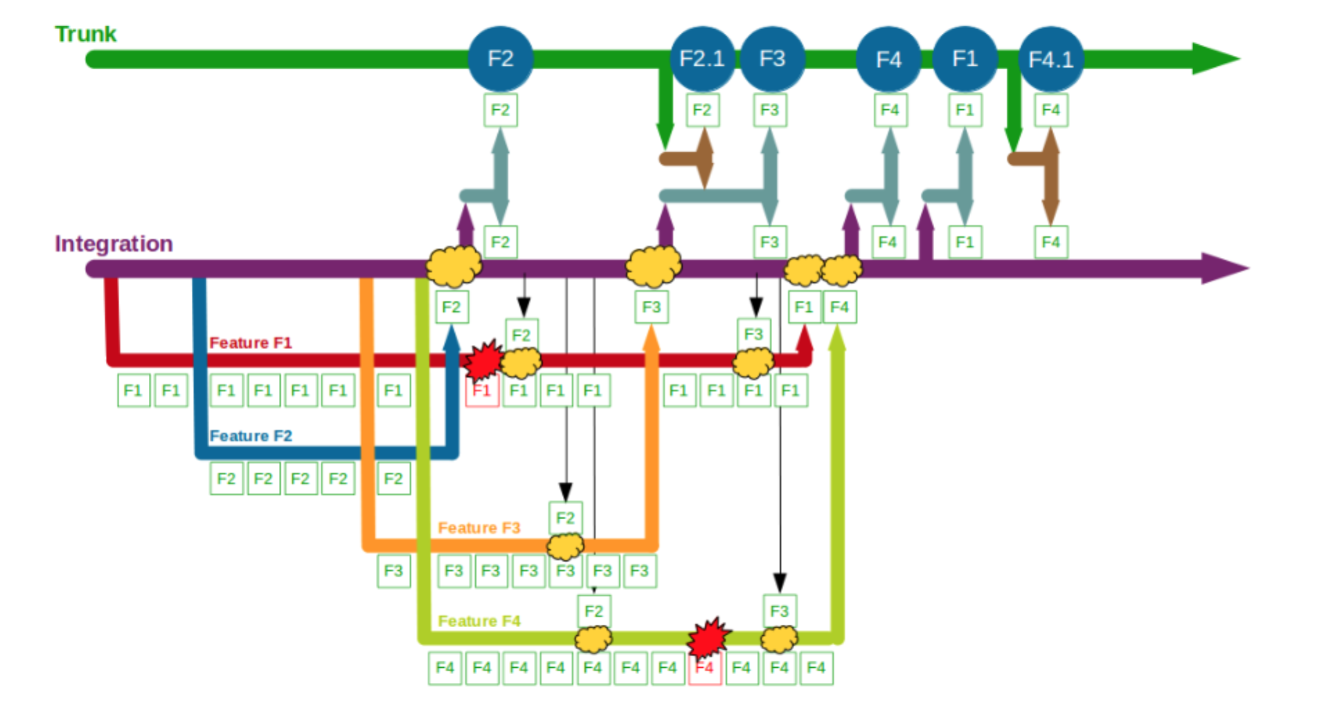

In this example F1, F2, F3, and F4 all enjoy uninterrupted development on their own feature branches. The use of an Integration branch reduces the complexity of each merge into Trunk, and allows the business stakeholders to re-schedule the F1 and F4 releases when circumstances change. However, the isolated development of F1, F2, F3, and F4 causes complex, time-consuming merges into Integration, and Trunk requires regression testing as it can differ from Integration – such as F4 being merged into Integration + F2 + F3 + F2.1 + F1 and Trunk + F2 + F2.1 + F3. The Company Accounts Service team might have used [Promiscuous Integration](http://www.martinfowler.com/bliki/FeatureBranch.html) on feature release to reduce the complexity of merging into Integration, but there would still be a need for regression testing on Trunk.

If the Company Accounts Service team used Type 3 Integration Feature Branching the use of feature release branches between Integration and Trunk could reduce the complexity of merging into Trunk, but regression testing would still be required on Trunk to garner confidence in a production release. Type 3 Integration Feature Branching also makes the version control strategy more convoluted for developers, as highlighted by Adam Ruka criticising Git Flow’s ability to “[create more useless merge commits that make your history even less readable, and add significant complexity to the workflow](http://www.endoflineblog.com/gitflow-considered-harmful)“.

The above example shows how Integration Feature Branching adds a costly, unpredictable phase into software development for little gain. The use of an Integration branch in Type 1 creates wasteful activities such as Integration merges and Trunk regression testing, which insert per-feature variability into delivery schedules. The use of feature branches in Type 2 discourages collaborative design and refactoring, leading to a gradual deterioration in codebase quality. The use of feature release branches in Type 3 lengthens feedback loops, increasing rework and lead times when defects occur.

Integration Feature Branching is entirely incompatible with [Continuous Integration](http://www.martinfowler.com/articles/continuousIntegration.html). Continuous Integration requires every team member to integrate and test their code on Trunk at least once a day in order to minimise feedback loops, and Integration Feature Branching is the polar opposite of this. While Integration Feature Branching can involve commits to Integration on a daily basis and a build server constantly verifying both Integration and Trunk integrity, it is vastly inferior to continuously integrating changes into Trunk. As observed by Dave Farley, “[you must have a single shared picture of the state of the system… there is no point having a separate integration branch](http://www.davefarley.net/?p=160)“.

1. **Please read case attached in following dropbox link. Explain the scenario explained in the case in less than 500 words.**

**Case Title: Resistance Against London Tube Map Commit History (a.k.a. Git Merge Hell): “It's so easy to end up with git commit history which looks like London tube map. Let's see how we end up with those big, ugly, meaningless commit histories and how to prevent having one.”**

[https://www.dropbox.com/s/exevslkwgn2sa9w/Resistance Against London Tube Map Commit History %28a.k.a. Git Merge Hell%29 .pdf?dl=0](https://www.dropbox.com/s/exevslkwgn2sa9w/Resistance%20Against%20London%20Tube%20Map%20Commit%20History%20%28a.k.a.%20Git%20Merge%20Hell%29%20.pdf?dl=0)

**8. Answer following short questions:**

**Question: How to delete a Git branch both locally and remotely?**

ahmed@DESKTOP-5MNJ1F7 MINGW64 ~/Desktop/GIT/Final Assessment/Final/GIT-Final-Exam (master)

$ git checkout -b feature1

Switched to a new branch 'feature1'

ahmed@DESKTOP-5MNJ1F7 MINGW64 ~/Desktop/GIT/Final Assessment/Final/GIT-Final-Exam (feature1)

$ git checkout master

Switched to branch 'master'

Your branch is up-to-date with 'origin/master'.

ahmed@DESKTOP-5MNJ1F7 MINGW64 ~/Desktop/GIT/Final Assessment/Final/GIT-Final-Exam (master)

$ git branch -d feature1

Deleted branch feature1 (was 8ae2730).

ahmed@DESKTOP-5MNJ1F7 MINGW64 ~/Desktop/GIT/Final Assessment/Final/GIT-Final-Exam (master)

$ git branch -dr origin/feature1

**Question: How do you undo the last commit?**

$git reset Head~1

**Question: How to Edit an incorrect commit message in Git?**

$ git commit –amend -m “new message”

**Question: What are the differences between 'git pull' and 'git fetch'?**

**Git Pull:** will pull down from a remote whatever you ask. Pull is a high-level request that runs ‘fetch’ then a ‘merge’ by default, or a rebase with ‘–rebase’.

**Git Fetch:** will have pulled down the remoteBranch and creates a local copy of a remote branch which you shouldn’t manipulate directly; instead create a proper local branch and work on that.

**Git pull = git fetch + git merge**

**Question: How do you rename the local branch?**

git branch -m oldBranchName newBranchName

**Question: How do I remove local files (Not in Repo) from my current Git**

To remove directories, run git clean -f -d or git clean -fd

To remove ignored files, run git clean -f -X or git clean -fX

To remove ignored and non-ignored files, run git clean -f -x or git clean -fx

**Question: How to Checkout remote Git branch?**

$ git checkout -b branchname origin/branchname

**Question: How do you create a remote Git branch?**

$ git checkout --track origin/branchname

**Question: How to Change the URL for a remote Git repository?**

git remote set-url origin <git://new.url.here>

**Question: How to Change the author of a commit in Git?**

git commit --amend --author= <author name>

**Question: How do you setup a script to run every time a repository receives new commits through push?**

Configure a script to run every time a repository receives new commits through push, one needs to define either a pre-receive, update, or a post-receive hook depending on when exactly the script needs to be triggered. Pre-receive hook in the destination repository is invoked when commits are pushed to it. Any script bound to this hook will be executed before any references are updated. This is a useful hook to run scripts that help enforce development policies. Update hook works in a similar manner to pre-receive hook, and is also triggered before any updates are actually made. However, the update hook is called once for every commit that has been pushed to the destination repository. Finally, post-receive hook in the repository is invoked after the updates have been accepted into the destination repository. This is an ideal place to configure simple deployment scripts, invoke some continuous integration systems, dispatch notification emails to repository maintainers, etc. Hooks are local to every Git repository and are not versioned. Scripts can either be created within the hooks directory inside the “.git” directory, or they can be created elsewhere and links to those scripts can be placed within the directory.

**Question: What is git rebase and how can it be used to resolve conflicts in a feature branch before merge?**

Rebasing is the process of moving a branch to a new base commit. The general process can be visualized as the following: From a content perspective, rebasing really is just moving a branch from one commit to another. When you perform a git rebase operation, you're typically moving commits around. Because of this, you might get into a situation where a merge conflict is introduced. That means that two of your commits modified the same line in the same file, and Git doesn't know which change to apply.

9.  **Complete the following steps using git commands on any repository of your choice. You can create your own. Please note the steps and git commands**

1. Make a fast forward merge

$ mkdir FinalExamPartE

$ cd FinalExamPartE

$ git init

$ touch A.txt

$ git add .

$ git commit -m "a1"

$ git checkout -b branch2

$ touch B.txt

$ echo "New file edited">B.txt

$ git add .

$ $ git commit -m "b1"

$ git checkout master

$ git merge branch2

1. Undo fast forward merge

$ git reset --hard HEAD~1

1. Make Commit on master

$ echo “This is a A.txt file”>A.txt

$ git add .

$ git commit -m "a2"

1. Make 3-way merge

$git checkout –b branch 2

$ touch c.txt

$ git add .

$ git commit –m “C1”

git checkout master

git merge branch1

git merge branch2

1. Undo Merge commit

Git reset --hard HEAD

1. Make rebase

$ Git checkout branch2

$ echo “This is a html file”>D.html

$ git add .

$ git commit –m “d1”

$ git checkout master

$ git rebase branch1

Following views will help you solve the problem

1. 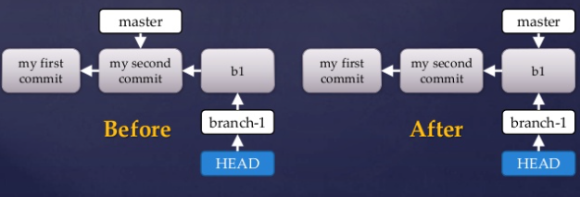

1. Step 2 &3

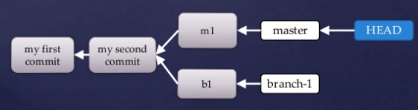

1. Step 4 &5

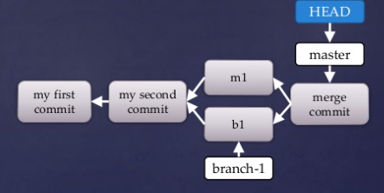

1. 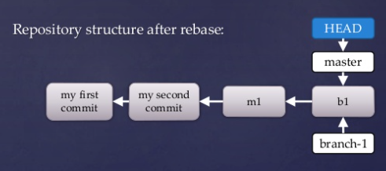After Rebase
2. **What is git cherrypicking and git stash. Execute the following steps. Push it to github and give repo address. Explain. Draw the flow if necessary.**
3. Git cherry-pick allows us to merge a single commit from one branch into another.

A stash is represented as a commit whose tree records the state of the working directory, and its first parent is the commit at HEAD when the stash was created.

**Git Cherrypick:**

git checkout -b exp

echo Not Cherry1 >> afile.txt

git commit -a -m NotCherry1

echo Cherry >> afile.txt

git commit -a -m Cherry

echo Not Cherry2 >> afile.txt

git commit -a -m NotCherry2

git checkout master

echo masterchange >> afile_master.txt

git add afile_master.txt

git commit -a -m "Master Change"

git log exp

git cherry-pick 3c8f

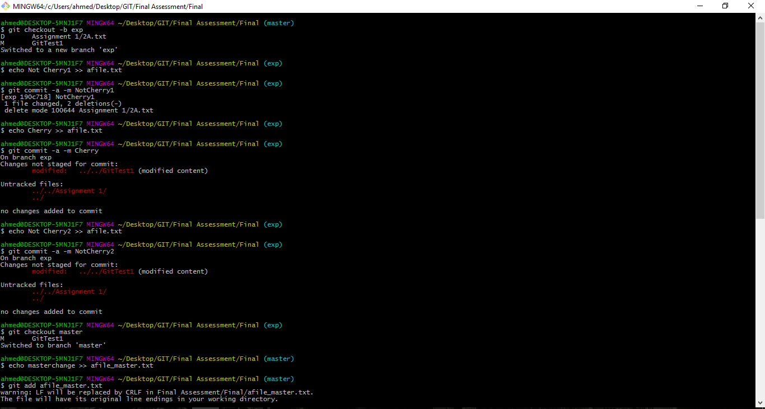

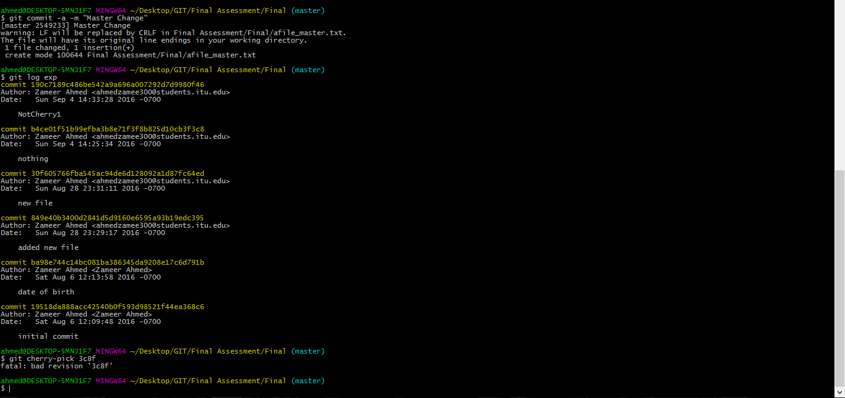

**Git Stash**

git-stash to save the current state of your work

git stash save "work in progress for foo feature"

echo “bug fix” >> afile.txt

git commit -a -m "fixed the bug"

git stash pop

